**ROHINI COLLEGE OF ENGINEERING AND TECHNOLOGY**

**DEPARTMENT OF COMPUTER SCIENCE & ENGINEERING**

**CCS342 - DEVOPS**

**LAB MANUAL**

**SEMESTER: V REGULATION:2021**

**PREPARED BY APPROVED BY**

**Mrs. PREETHI A R DR.I. MICHAEL REVINA**

**Assistant Professor Associate Professor & Head of the Department**

**Department of CSE Department of CSE**

**ROHINI COLLEGE OF ENGINEERING AND TECHNOLOGY**

**VISION**

* To be a centre of excellence in engineering and technology
* To produce technocrats who are technically competent, ethically strong for advancement of the society.

**MISSION**

* To provide quality education in emerging technologies in accordance with industrial trends.
* To build good research capabilities and support new innovations.

**DEPARTMENT OF COMPUTER SCIENCE AND ENGINEERING**

**Vision**

* To create young software professionals to compete the global challenges in the field of computer science and engineering and be researchers to meet the needs of society.

**Mission**

* To provide quality education to develop software for real time problems in scientific and business application for various needs of industry.
* To provide learning ambience to enhance innovations, problem solving skills, leadership qualities,team spirit and ethical responsibility to serve the society.

**PEO**

* PEO1- The graduates will be able to design and to adapt modern tools to innovate ideas and develop computational solutions for technological problems.
* PEO2- The graduates will be able to develop professional skills for employment and understand the need of lifelong learning for a successful professional career.
* PEO3- To develop an ability to become a successful professional, entrepreneur and urge for pursuing higher studies.

**Program outcomes**

1. **Engineering knowledge**: Apply the knowledge of mathematics, science, engineering fundamentals and an engineering specialization to the solution of complex engineering problems.
2. **Problem analysis**: Identify, formulate, review research literature, and analyze complex engineering problems reaching substantiated conclusions using first principles of mathematics, natural sciences, and engineering sciences.
3. **Design/development of solutions**: Design solutions for complex engineering problems and design system components or processes that meet the specified needs with appropriate consideration for the public health and safety, and the cultural, societal, and environmental considerations.
4. **Conduct investigations of complex problems**: Use research-based knowledge and research methods including design of experiments, analysis and interpretation of data, and synthesis of the information to provide valid conclusions.
5. **Modern tool usage**: Create, select, and apply appropriate techniques, resources, and modern engineering and IT tools including prediction and modeling to complex engineering activities with an understanding of the limitations.
6. **The engineer and society**: Apply reasoning informed by the contextual knowledge to assess societal, health, safety, legal and cultural issues and the consequent responsibilities relevant to the professional engineering practice.
7. **Environment and sustainability**: Understand the impact of the professional engineering solutions in societal and environmental contexts, and demonstrate the knowledge of, and need for sustainable development.
8. **Ethics**: Apply ethical principles and commit to professional ethics and responsibilities and norms of the engineering practice.
9. **Individual and team work**: Function effectively as an individual, and as a member or leader in diverse teams, and in multidisciplinary settings.
10. **Communication:** Communicate effectively on complex engineering activities with the engineering community and with society at large, such as, being able to comprehend and write effective reports and design documentation, make effective presentations, and give and receive clear instructions.
11. **Project management and finance:** Demonstrate knowledge and understanding of the engineering and management principles and apply these to one‘s own work, as a member and leader in a team, to manage projects and in multidisciplinary environments.
12. **Life-long learning:** Recognize the need for, and have the preparation and ability to engage in independent and life-long learning in the broadest context of technological change.

**COURSE OBJECTIVES**

**SYLLABUS**

**CCS342 - DEVOPS LAB**

| **S.No.** | **Name of the Experiment** |
| --- | --- |
| 1 | Create Maven Build pipeline in Azure |
| 2 | Run regression tests using Maven Build pipeline in Azure |
| 3 | Install Jenkins in Cloud |
| 4 | Create CI pipeline using Jenkins |
| 5 | Create a CD pipeline in Jenkins and deploy in Cloud |
| 6 | Create an Ansible playbook for a simple web application infrastructure |
| 7 | Build a simple application using Gradle |
| 8 | Install Ansible and configure ansible roles and to write playbooks |

**COURSE OUTCOMES:**

**[Cognitive Level K1- remember, K2- Understand, K3- Apply, K4 - Analyze, K5- Evaluate, K6- Synthesize]**

**On completion of the course, the student will have the ability to:**

| **COs** | **Course Outcomes** | **K Level** |
| --- | --- | --- |
| CO1 | Apply CI/CD principles to build and test applications using Azure DevOps pipelines with Maven | K3 |
| CO2 | Develop and automate simple Java applications using build tools like Maven and Gradle | K3 |
| CO3 | Implement automated build and deployment processes by configuring CI/CD pipelines in Jenkins | K3 |
| CO4 | Use Ansible playbooks and roles to provision and configure infrastructure for web applications | K3 |
| CO5 | Develop and execute automation scripts and playbooks to efficiently manage infrastructure and application deployment. | K3 |

**INDEX**

| **S.No.** | **Name of the Experiment** | **Page No.** | **Signature** |
| --- | --- | --- | --- |
| 1 | Create Maven Build pipeline in Azure |  |  |
| 2 | Run regression tests using Maven Build pipeline in Azure |  |  |
| 3 | Install Jenkins in Cloud |  |  |
| 4 | Create CI pipeline using Jenkins |  |  |
| 5 | Create a CD pipeline in Jenkins and deploy in Cloud |  |  |
| 6 | Create an Ansible playbook for a simple web application infrastructure |  |  |
| 7 | Build a simple application using Gradle |  |  |
| 8 | Install Ansible and configure ansible roles and to write playbooks |  |  |

**Ex.No.:1 Create Maven Build pipeline in Azure**

**AIM:**

To create and configure a Maven Build Pipeline in Azure DevOps, which automates the process of building, compiling, testing, and packaging a Java application, ensuring continuous integration (CI) and seamless deployment.

**PROCEDURE:**

**Step1:** Create a maven project

* Give Group id and artifact Id
* Select destination folder to save your project

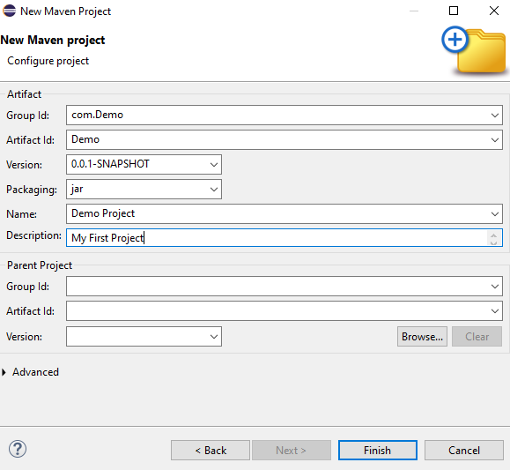

**Step 2:** Develop a class file

* Right click main project directory
* New → give classname →
* Select main method check box → finish
* Develop the coding for any problem.

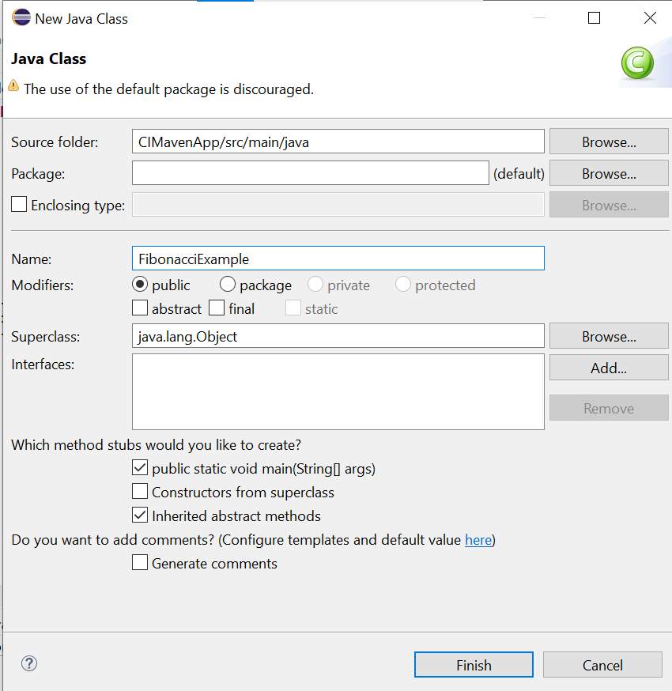

Example: Java program to calculate and display the Fibonacci sequence:

public class FibonacciExample {

public static void main(String[] args) {

int n = 10; // number of terms to display

int first = 0, second = 1;

System.out.println("Fibonacci Sequence up to " + n + " terms:");

for (int i = 1; i <= n; i++) {

System.out.print(first + " ");

int next = first + second;

first = second;

second = next;

}

}

}

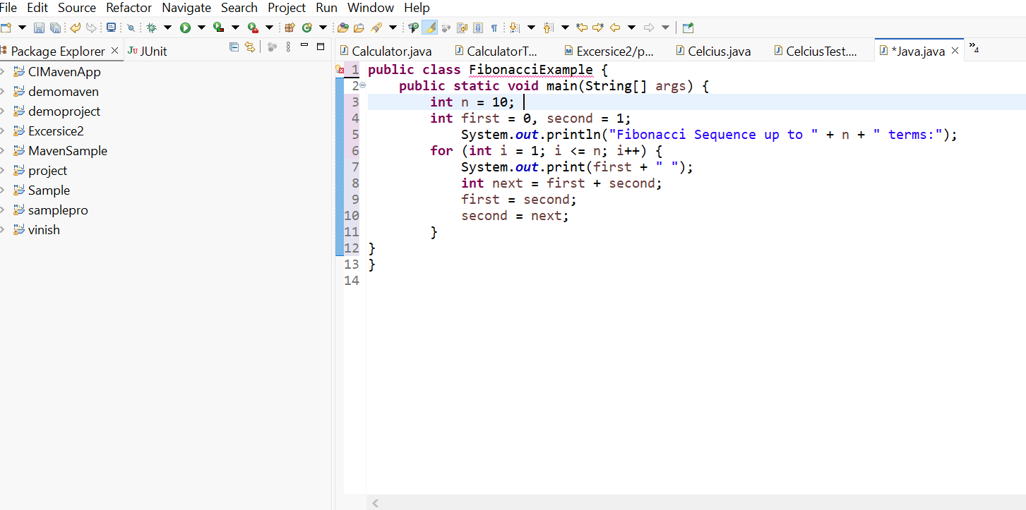

**Step 3: Run the class file**

* Right click class.java → run as → Java application
* And view the output whether it is correct.

Output (for n = 10):

Fibonacci Sequence up to 10 terms:

0 1 1 2 3 5 8 13 21 34

**Step 4: Build the project**

Right click the main project directory àRunAsàmaven buildà

Give goal → clean install

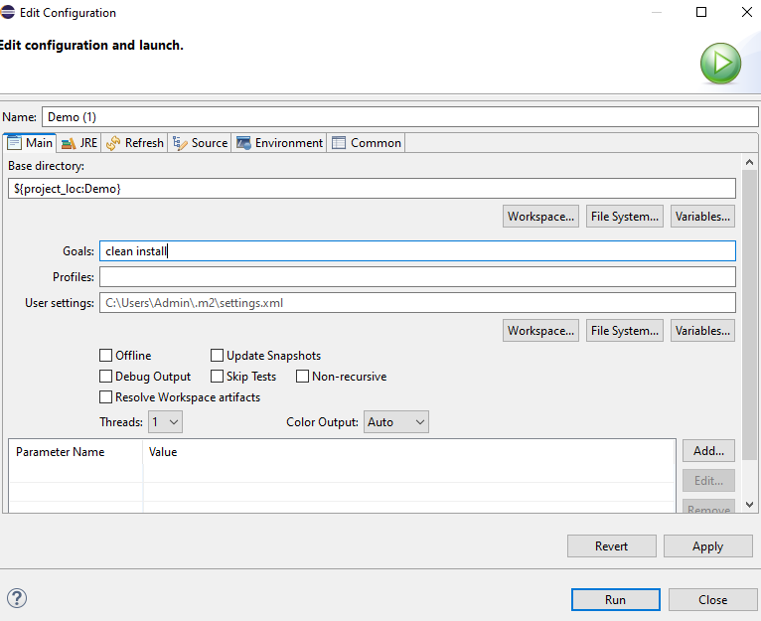

Build process will be completed

Check the status ---BUILD SUCCESS—

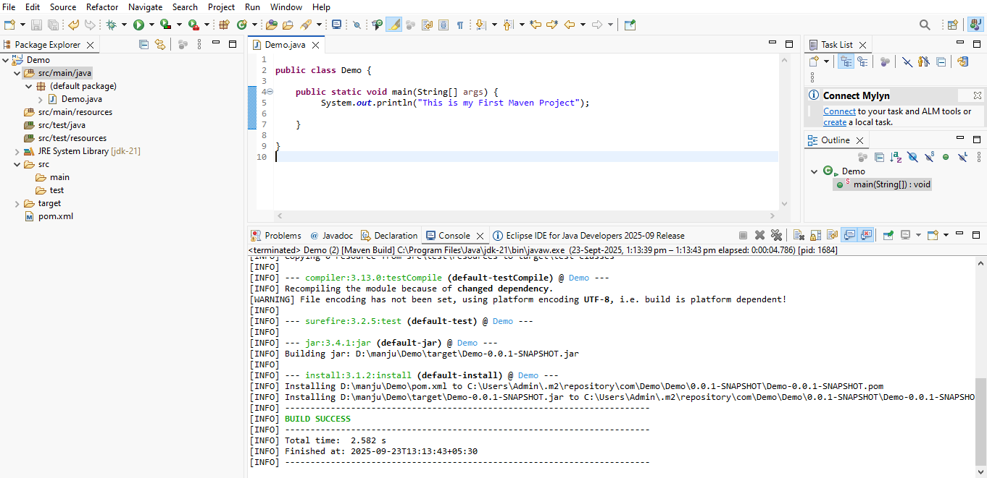

**Step 8: Post the project in github repository using git**

(i) Open gitbash, Convert your project directory as a git repository by giving the following commands.

$git init

$ls (to list out all files)

$status (to check the status of the files whether committed or not)

vi .gitignore (to create a file to collect all unwanted files)

target /*

.classpath

.settings

Save the file :wq

$ls -a

$git add . (to bring all files into staging area)

$ git commit -m”message”

(ii)Connect your local repository with github repository

$ git remote add origin “link”.git

(iii) Push your local repository files into github repository

$ git push -u origin master

(iv) Now you will be asked to login to github by giving a verification code.

Now set up over



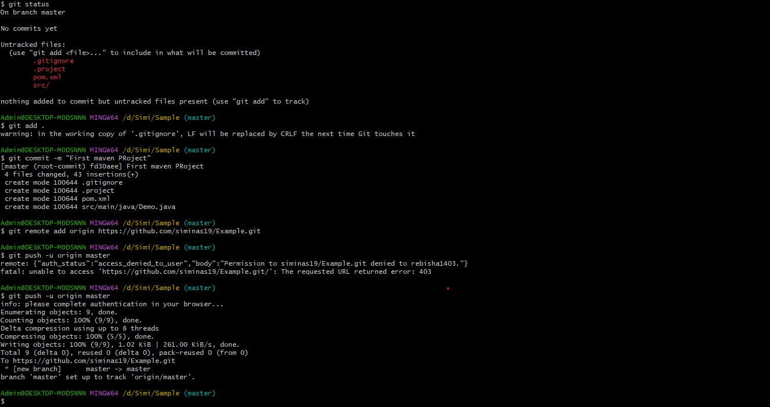

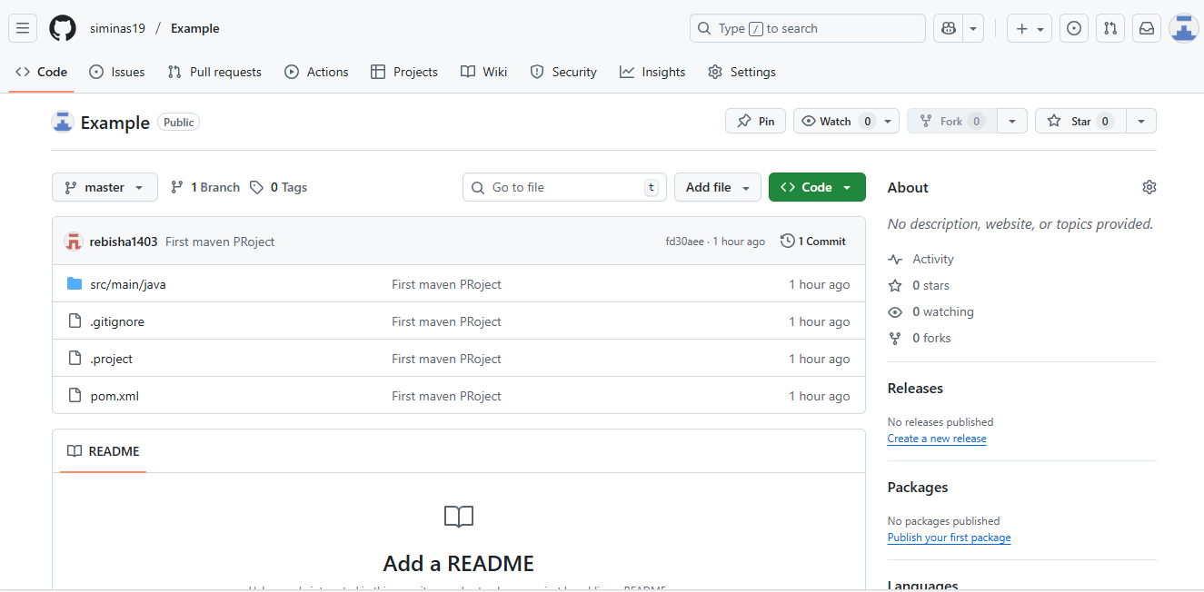

**Step 9: Run the project in Azure Devops.**

* Open Azure devops cloud platformàsign in (through Microsoft account or github account)
* Create an organization →create a project
* Create a pipeline → select type of repository → github
* Select project type → maven → now select → your github repository
* Now your projects yaml file will be opened
* Run the code

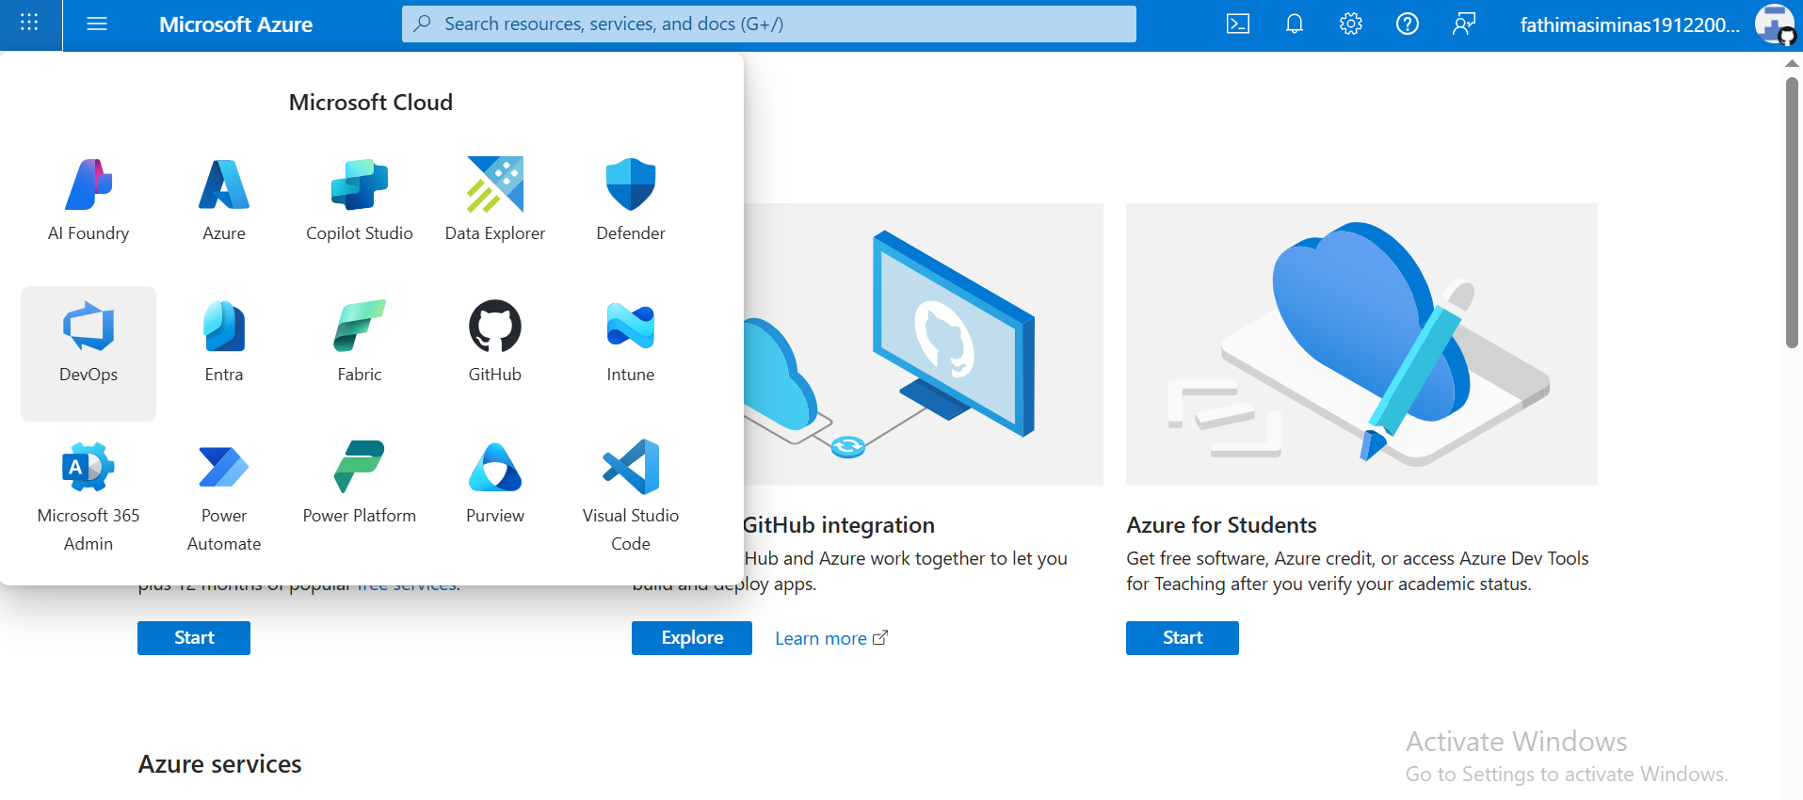

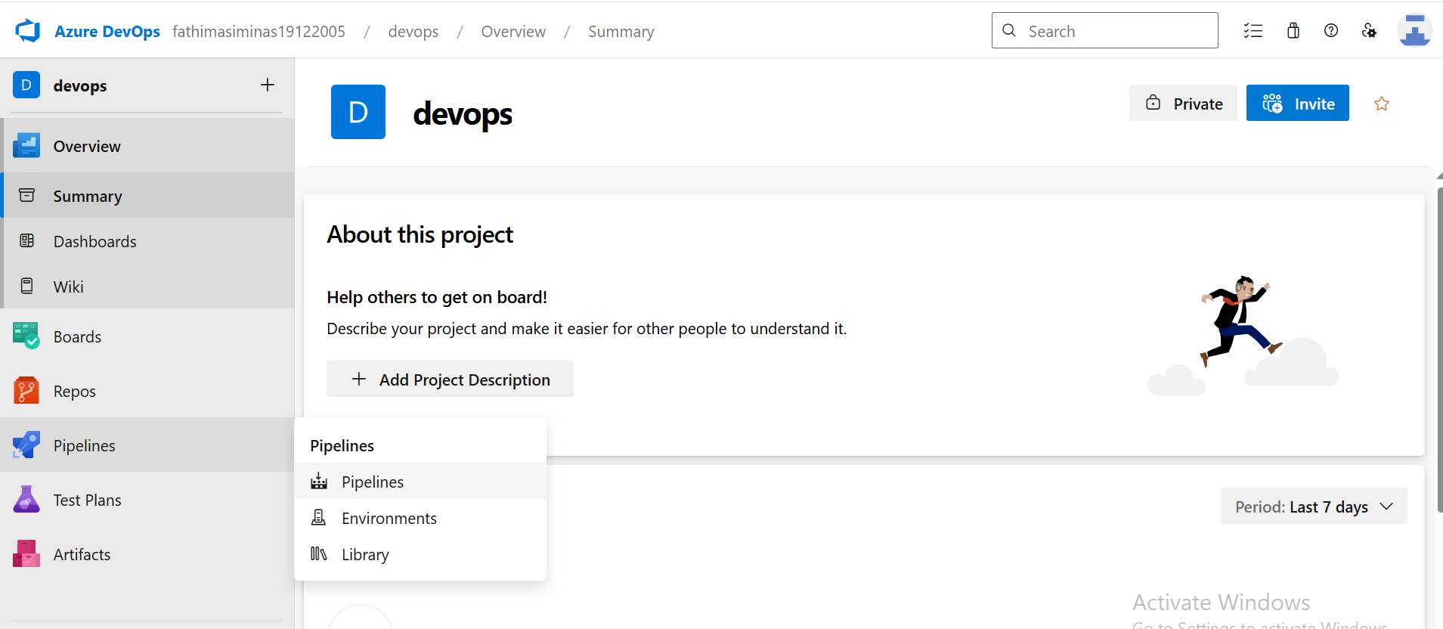

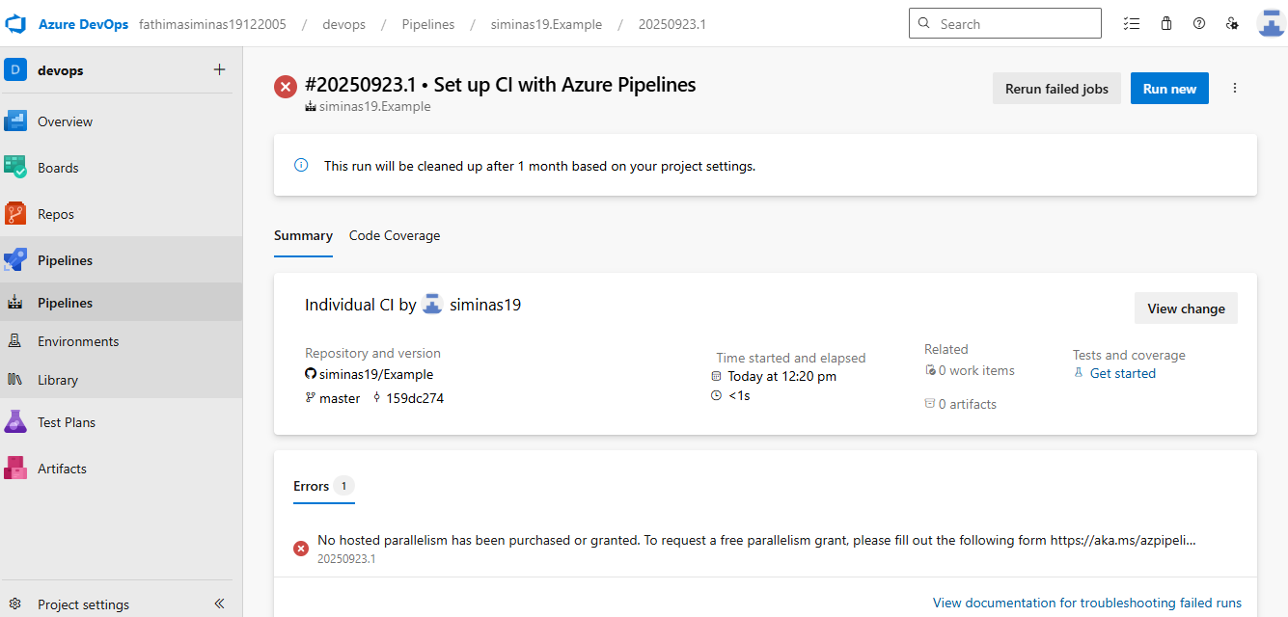

**RESULT:**

Thus the Maven build pipeline has been completed successfully by compiling the code, running tests, and generating the packaged application artifacts.

**Ex.No.: 2 Run regression tests using Maven Build pipeline in Azure**

**AIM:**

To set up a Maven build pipeline in Azure DevOps and run regression tests automatically, so that software changes can be tested quickly and errors can be found early during development.

**PROCEDURE**

**Step 1:** Create a maven Application by Clicking File -> New -> Maven Project

Select Skip Archetype and Click next.

Give the Group id and Artifact ID

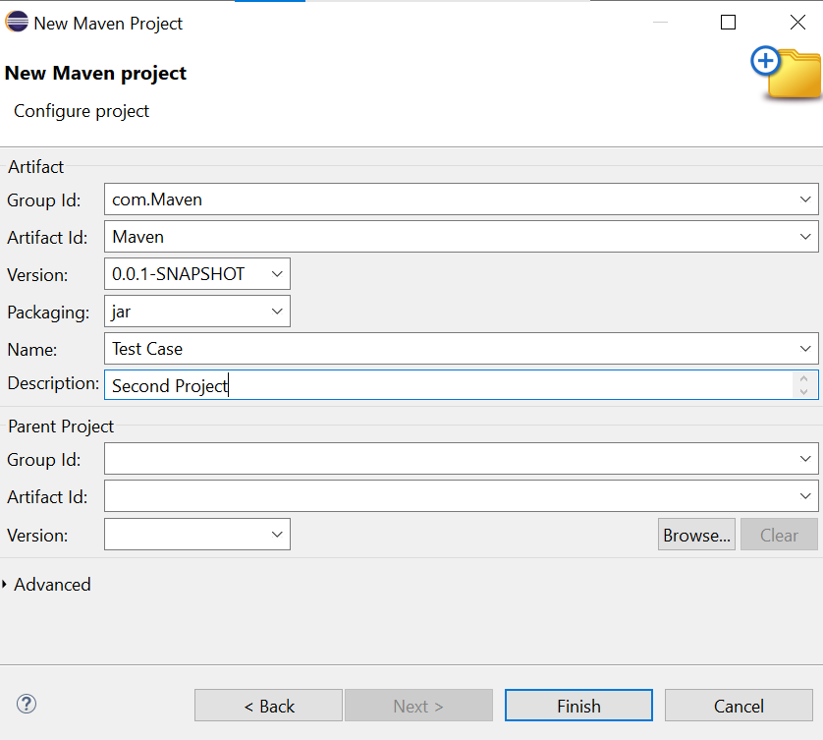

**Step 2:** Create a java class by right clicking the source/main package and select the default main method and click Finish

**Step 3:** Type the java program for conversion of temperature

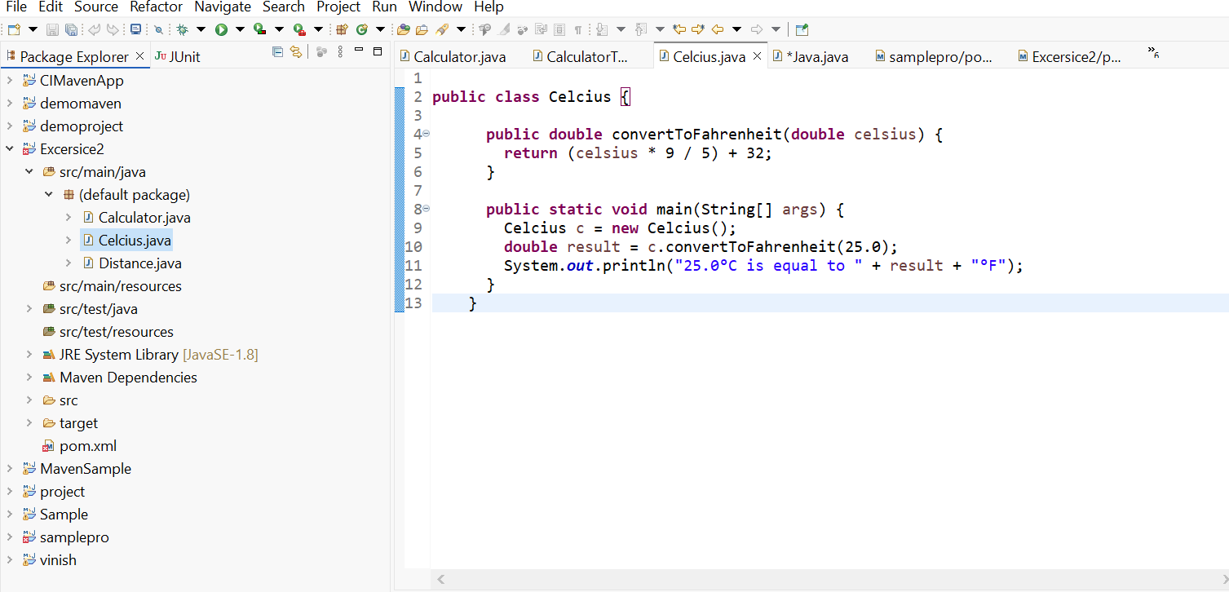

**Step 4:** Run the java class file as java application

**Step 5:** Create a test class with the same name as Class name following the word Test under the test package

**Step 6:** Add the junit dependency in pom.xml file

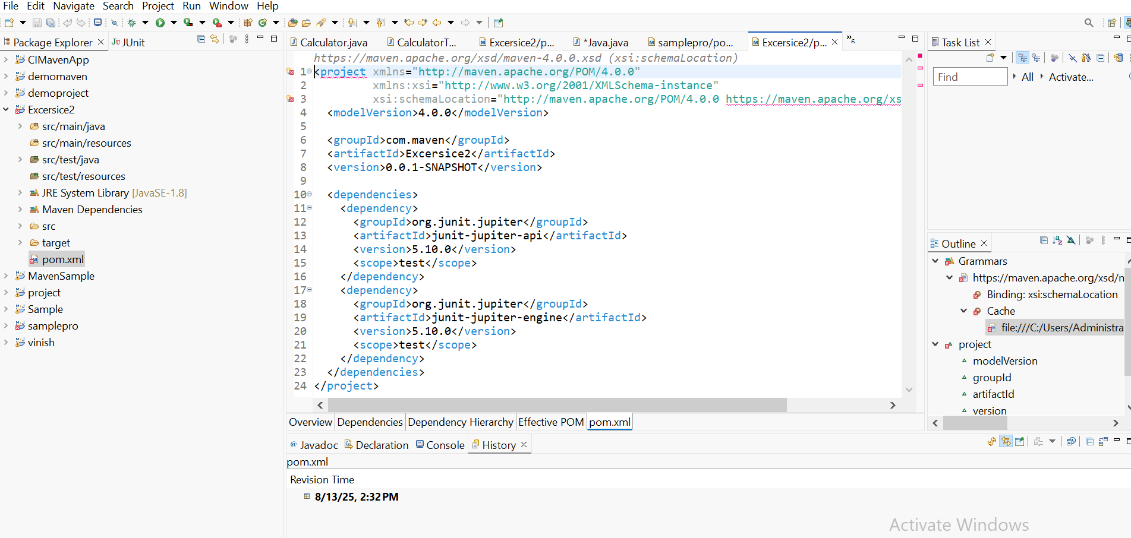

**Step 7:** Type the test cases in the test file

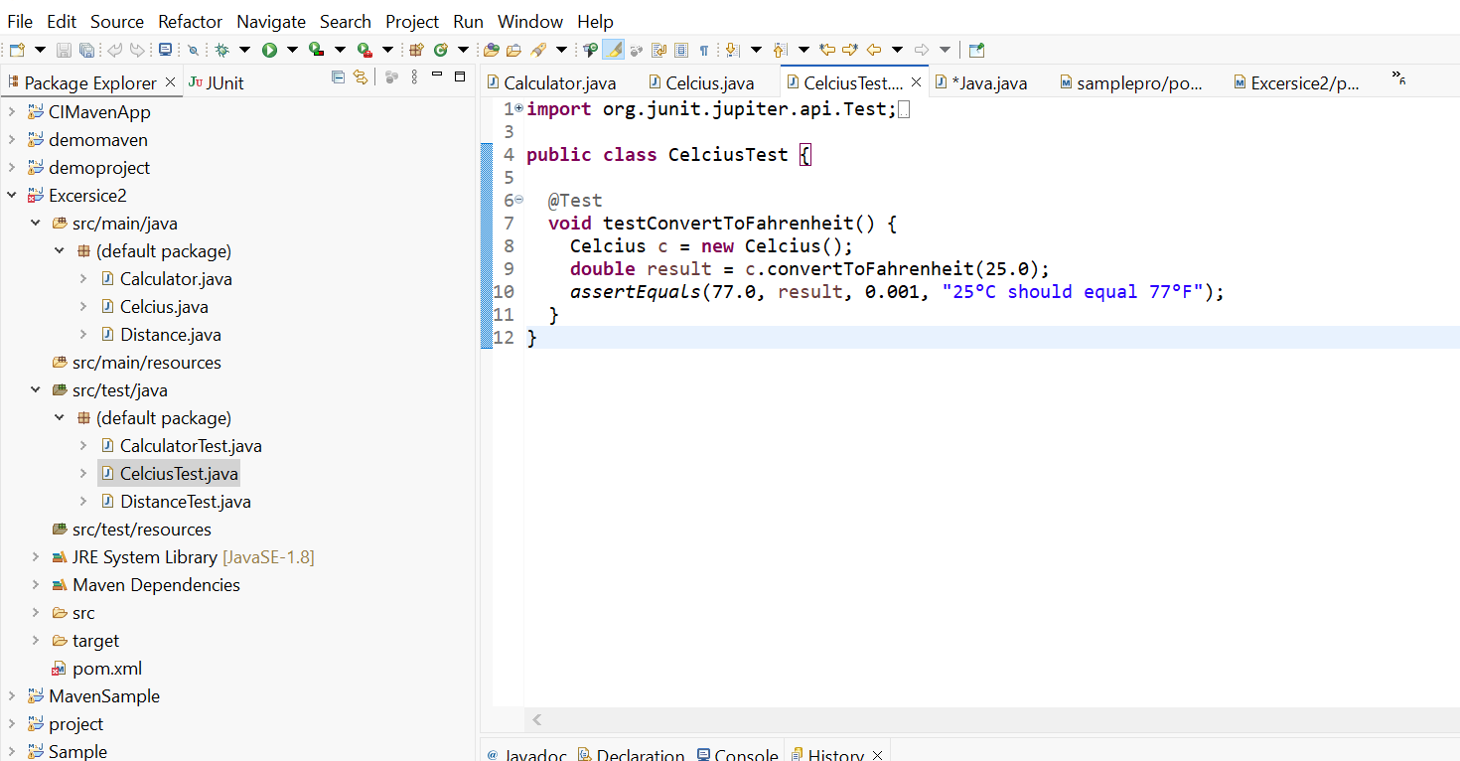

**Step 8:** Run as junit test case

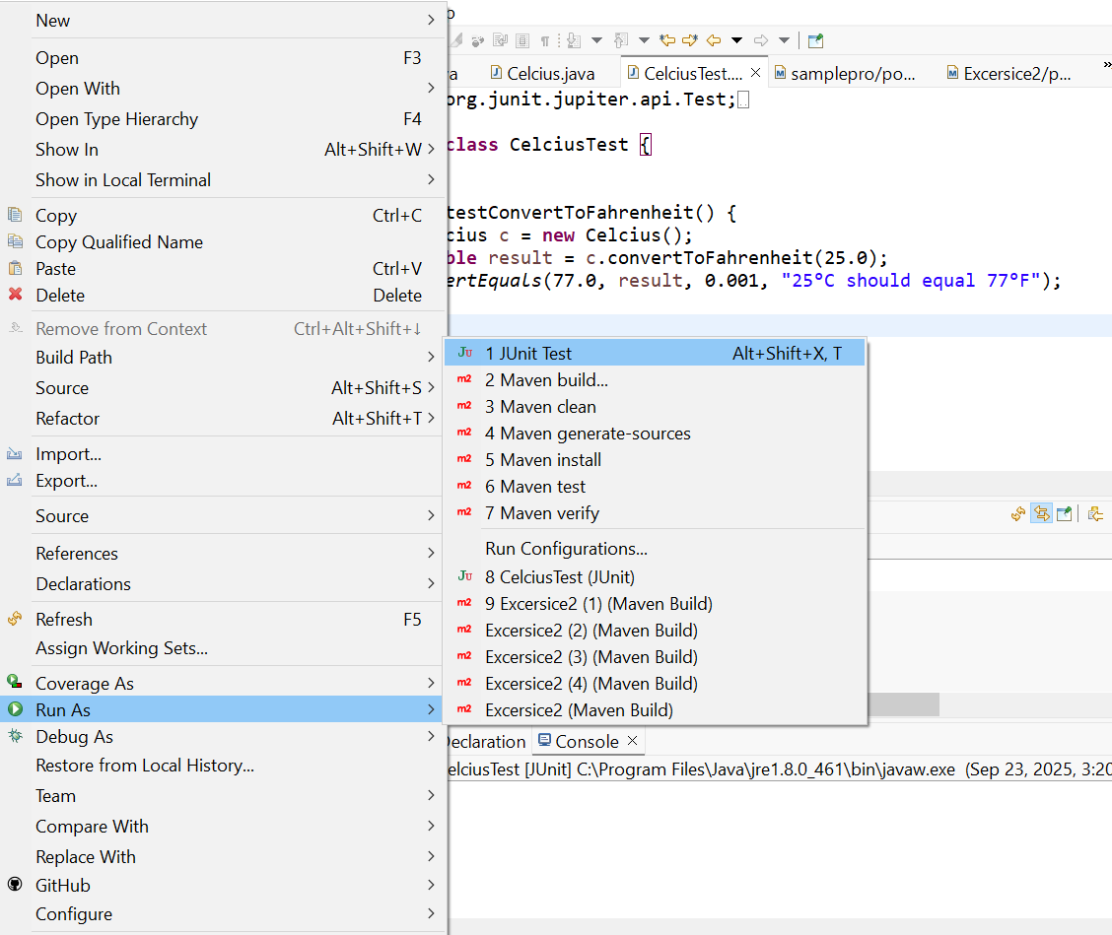

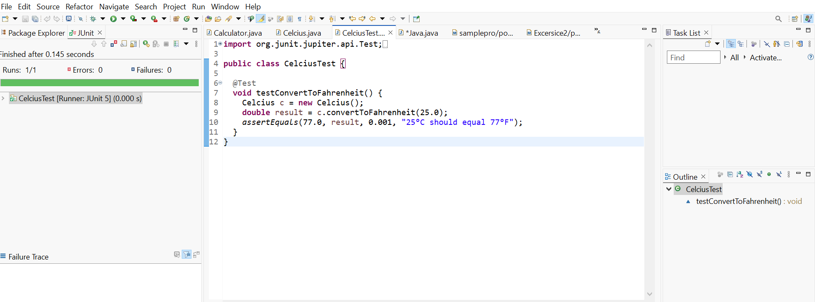

**Step 9:** Build the Maven Project by the goals clean and install

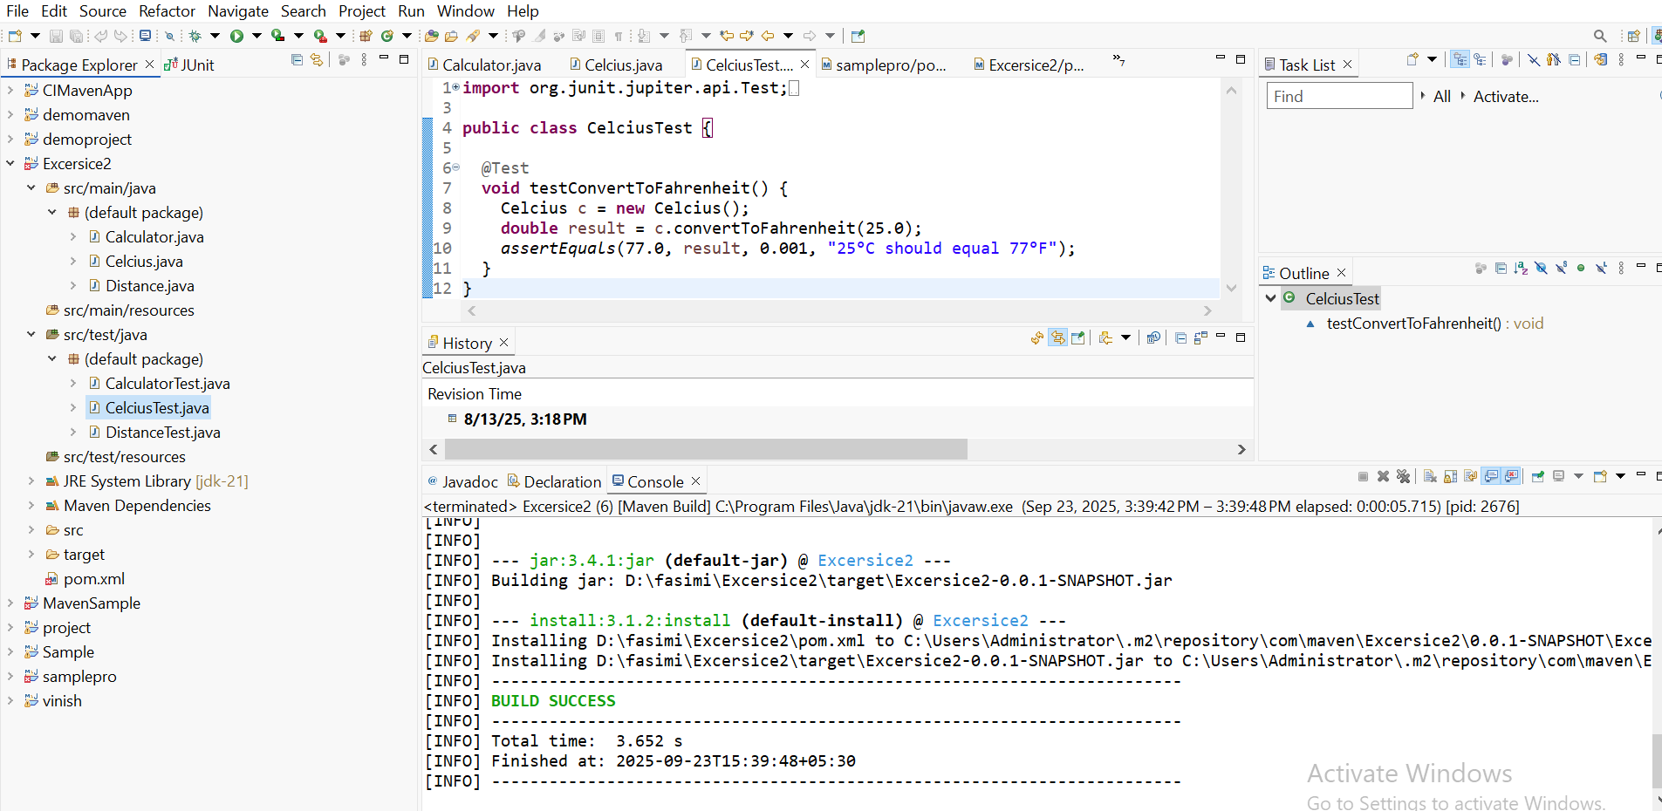

**Step 10:** Open the project folder and right click and select git bash

**Step 11:** Execute the following git commands to add the files to staging area and to commit

$ git init

$ ls -a

$ vi .gitignore and add the files target/*, .classpath, .settings

Save and exit the text file

$ git status

$ git add .

$ git commit -m “ Initial Message”

**Step 12:** Open the github account and create a new repository

**Step 13:** Execute the commands in git bash to clone the git with the created github repository and to push the files to github repository

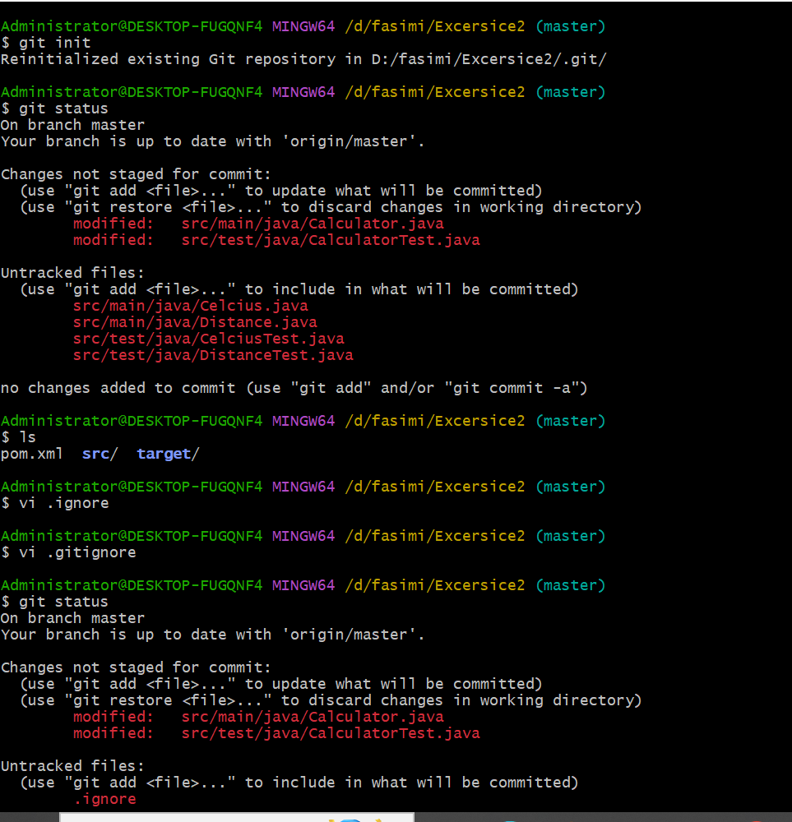

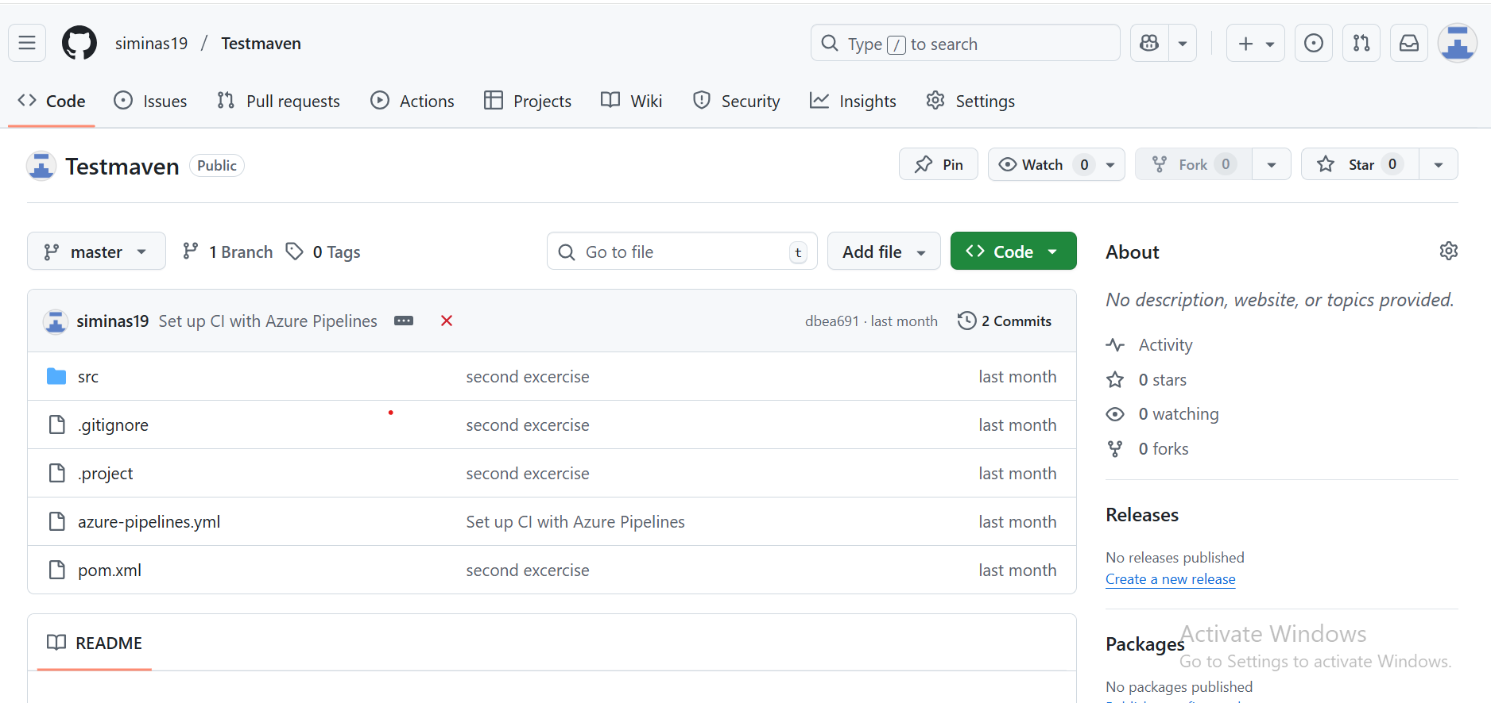

**Step 14:** Open Azure Devops by signing in and create a pipeline

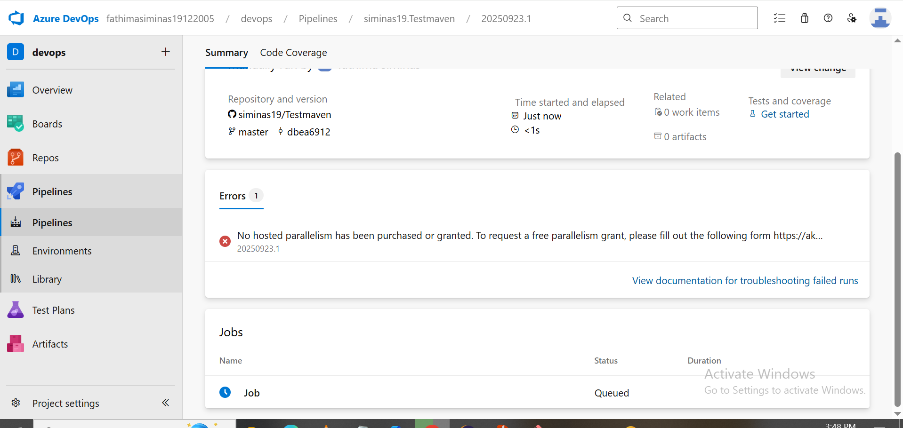

**RESULT:**

Thus the Maven build pipeline executed the regression tests successfully, validating that all existing functionalities work as expected without any failures.

**Ex.No.: 3 Install Jenkins in Cloud**

**AIM:**

To install and configure Jenkins, an open-source automation server, to enable continuous integration and continuous delivery (CI/CD) of software projects.

**PROCEDURE:**

**Step 1:** Go to the website <https://www.jenkins.io/download/> and select the platform on which Jenkins to be installed.

**Step 2:** Once the download is completed, run the jenkins.msi installation file.

**Step 3:** The setup wizard starts as follows. Click the Next button to proceed.

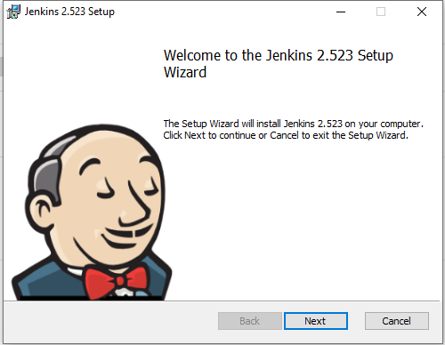

**Step 4:** Now, select the destination folder for installation and click Next button.

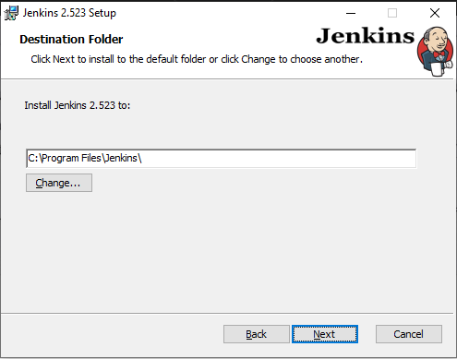

**Step 5:** On the next screen, Select RunService as LocalSystem.

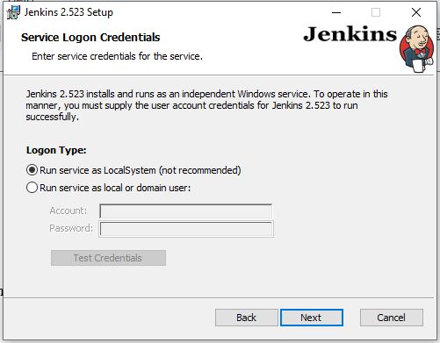

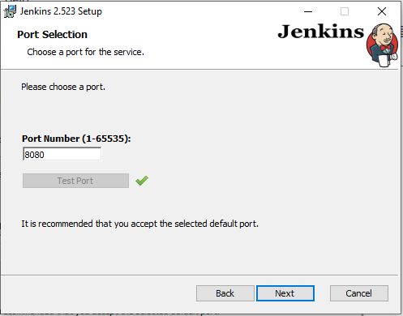

Click the next button. Select the default JDK folder by clicking on Next Button. Finally click on install to start installation.

**Step 6:** Once the installation is complete, Click finish to exit the installation wizard.

After completing the installation process, we need to unlock Jenkins.

**Unlocking Jenkins:**

**Step 1:** Open web browser and navigate to the port number by giving the url https:localhost:8080/

**Step 2:** Navigate to the location of the system specified by the Unblock jenkins page. The location is :

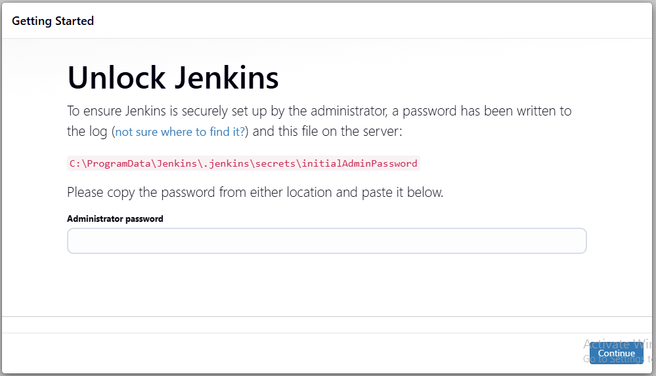

**Step 3:** Open the initialAdminPassword in Notepad and copy it. Paste it to the Administrator Password on the Unblock Jenkins page and click continue to proceed.



Step 4: Enter the required information on the Create First Admin User page. Click Save and Continue to proceed.

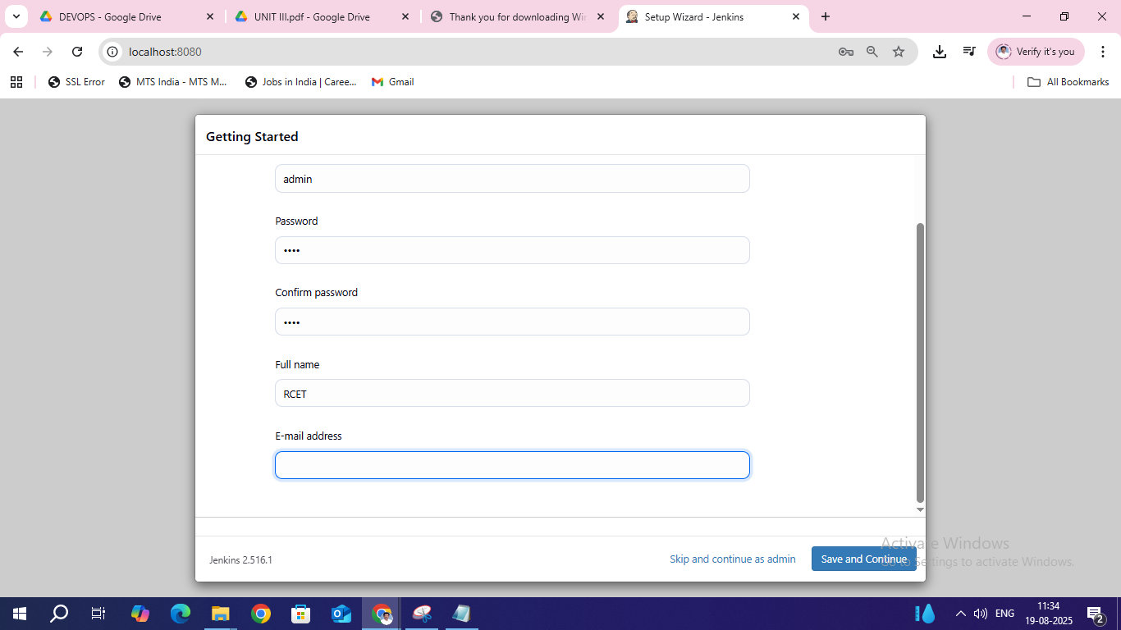

Step 5: On the Instance Configuration page confirm the port number 8080 and click save and finish to finish the initial customization.

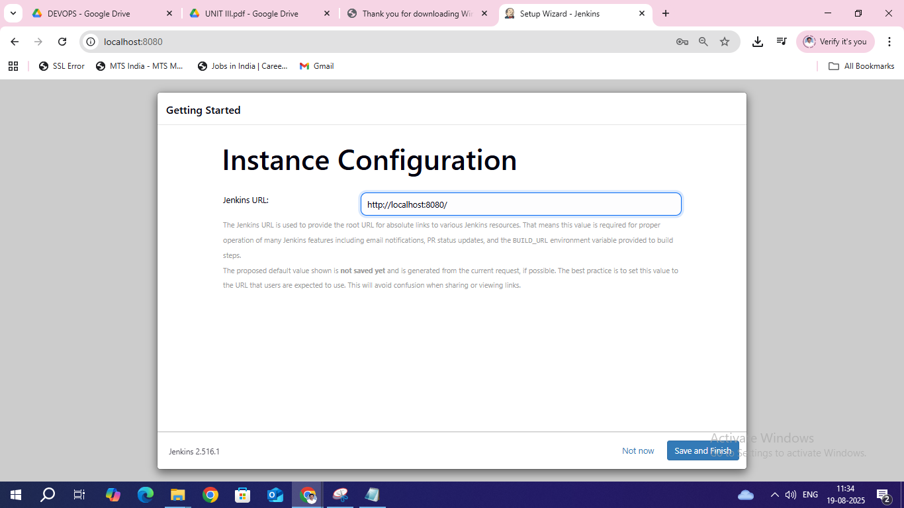

Jenkins configuration is done.

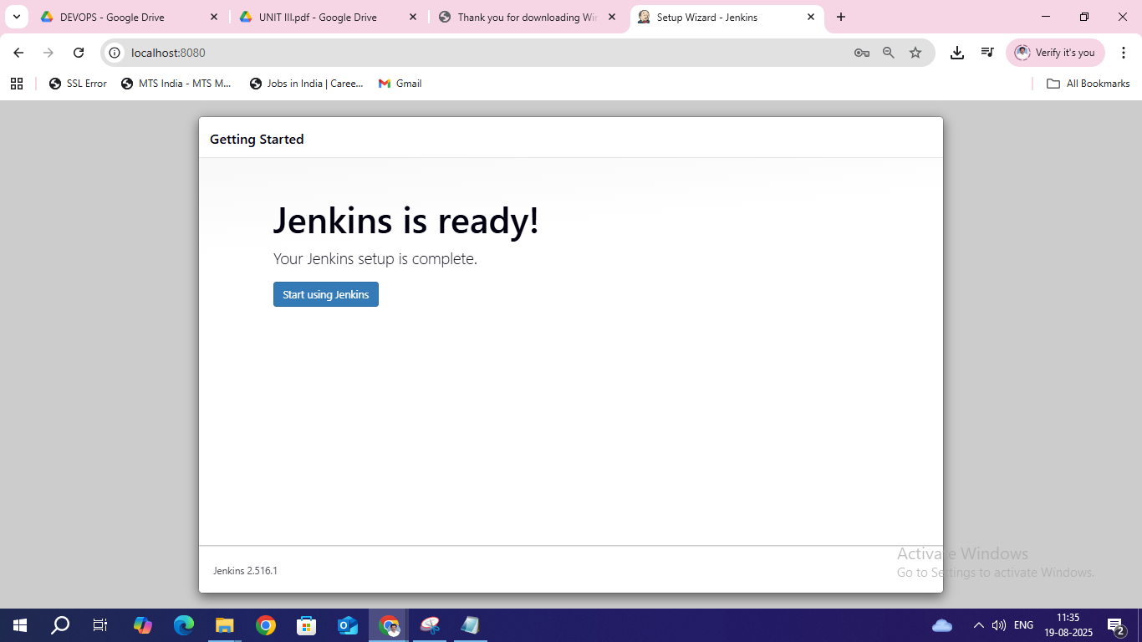

Jenkins dashboard appears as follows.

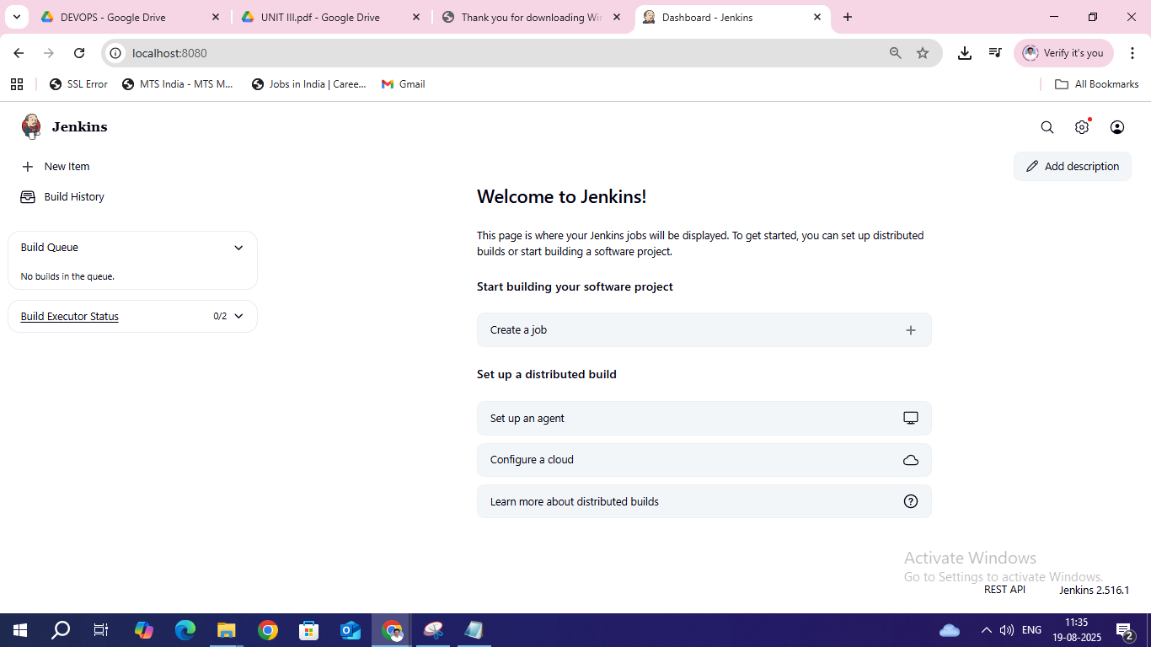

**Result:**

Thus Jenkins was successfully installed on the system and the Jenkins service was started and accessed through a web browser using the default port 8080.

**Ex.No.: 4 Create CI pipeline using Jenkins**

**AIM:**

To create a Continuous Integration (CI) pipeline using Jenkins that automatically fetches source code from a repository, compiles the application, runs tests, and generates build artifacts, ensuring early detection of errors and improving software quality.

**PROCEDURE:**

**Step 1:** Create a Maven Project by clicking File -> New -> Maven Project

Select the skip archetype and Click Next

Provide the groupId and artifactId

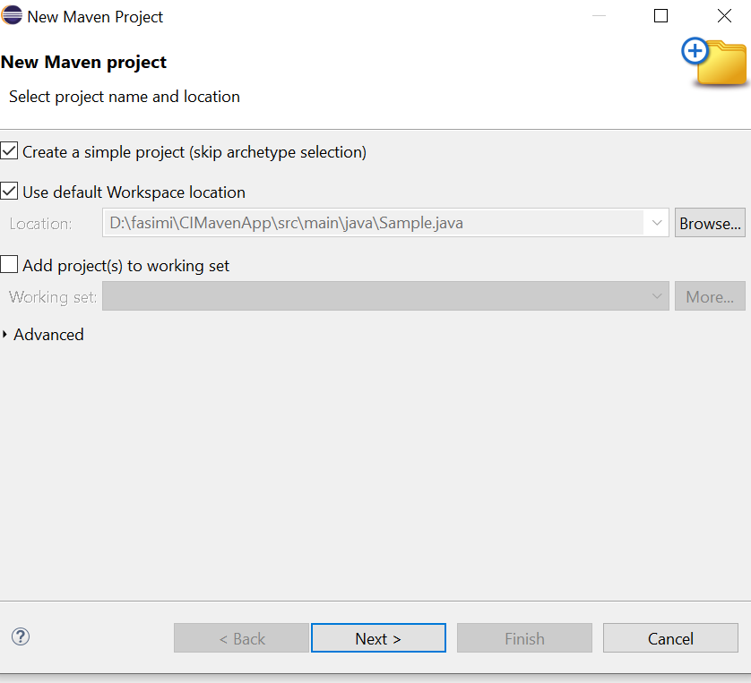

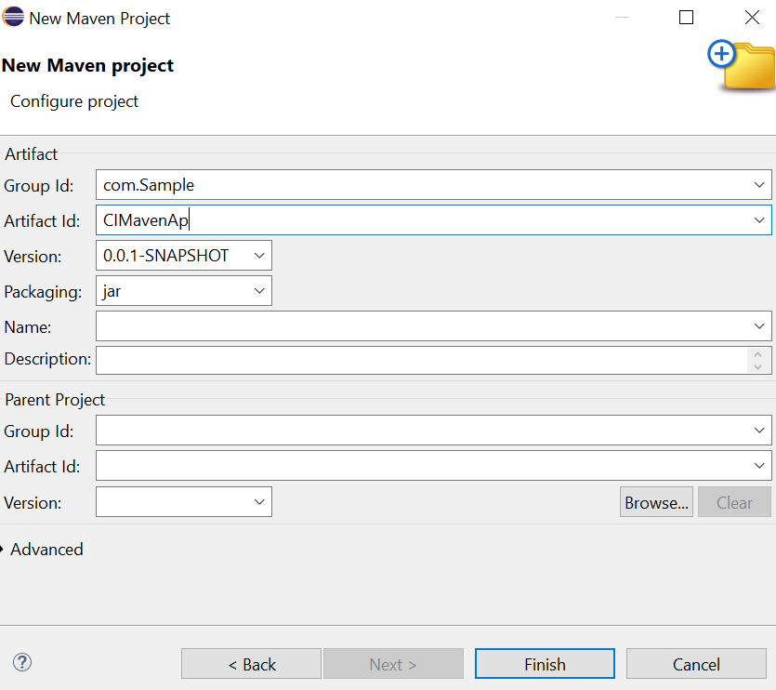

**Step 2:** Create a java class by right clicking the src/main package and select the main method

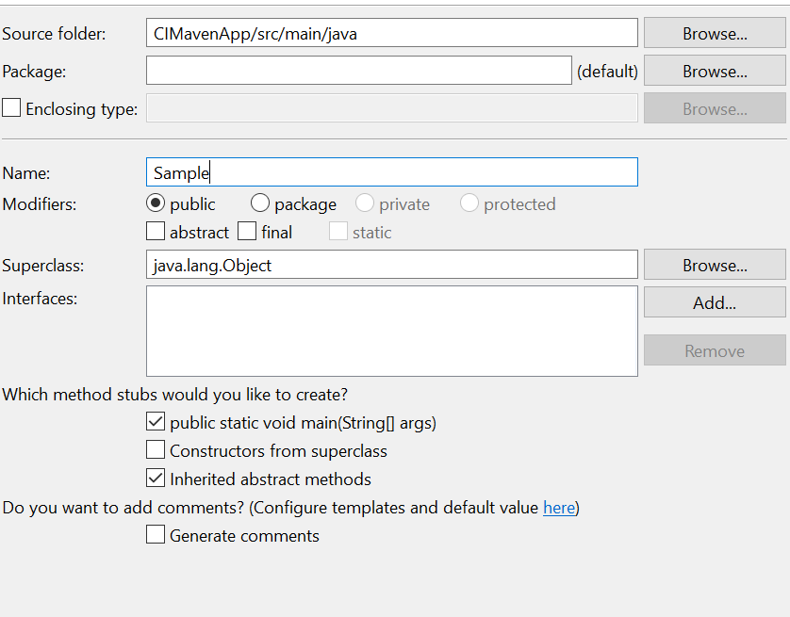

**Step 3:** Type a java program as follows

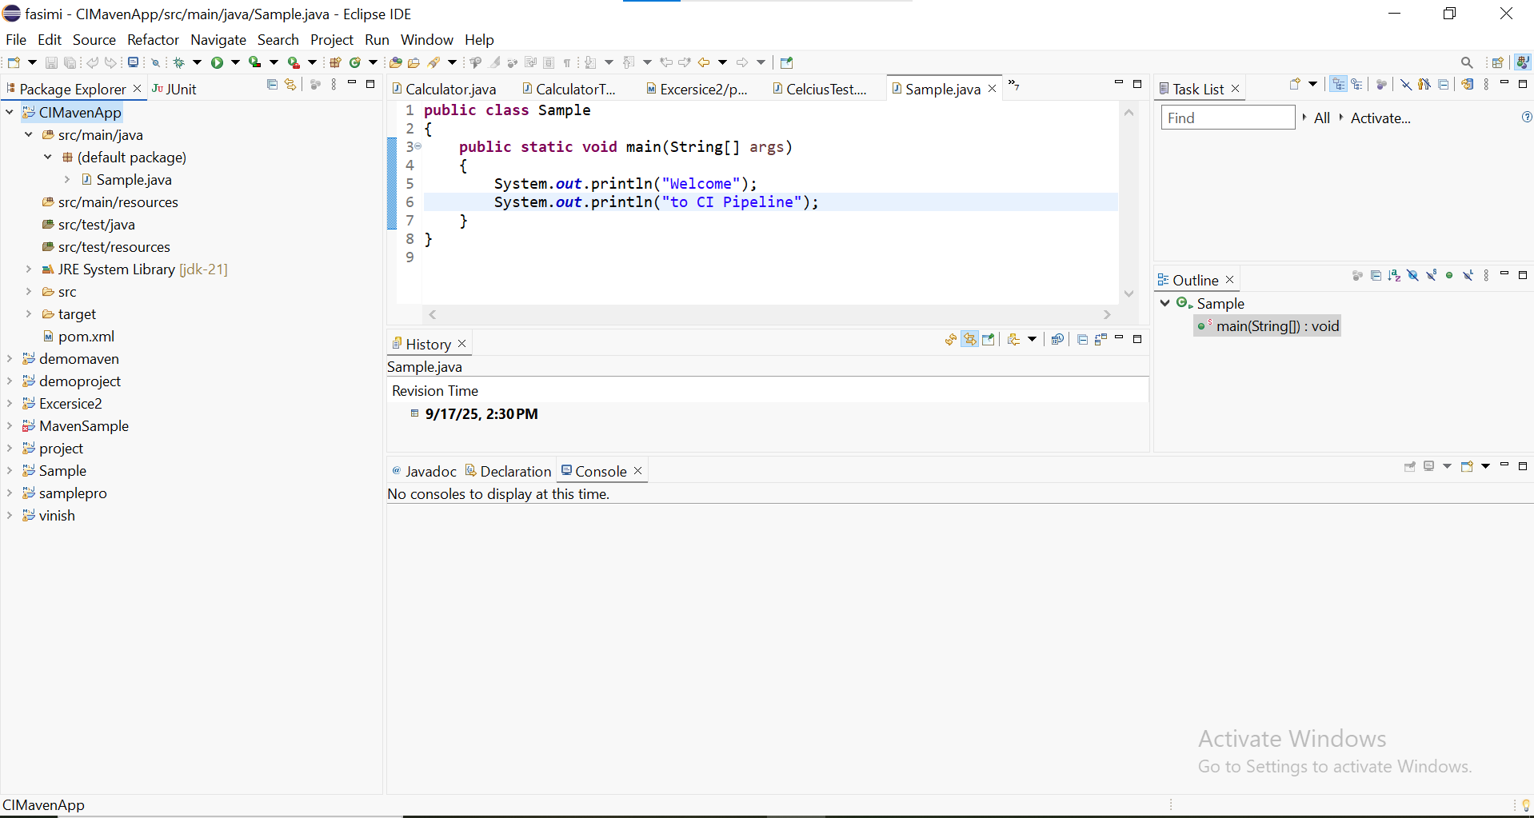

**Step 4:** Run the program as java application by right clicking the java file

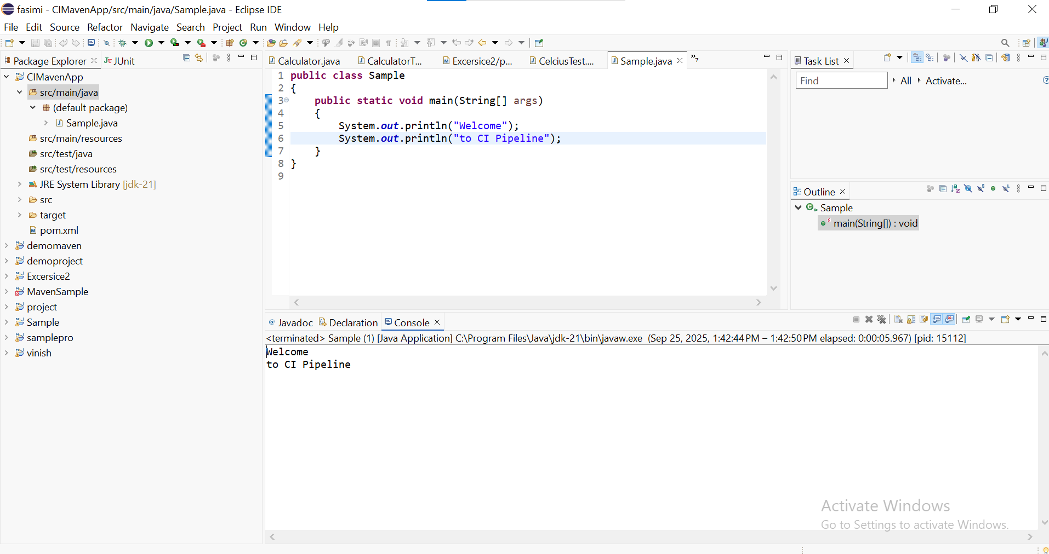

**Step 5:** Right click the project and build the maven by providing the goals clean and install

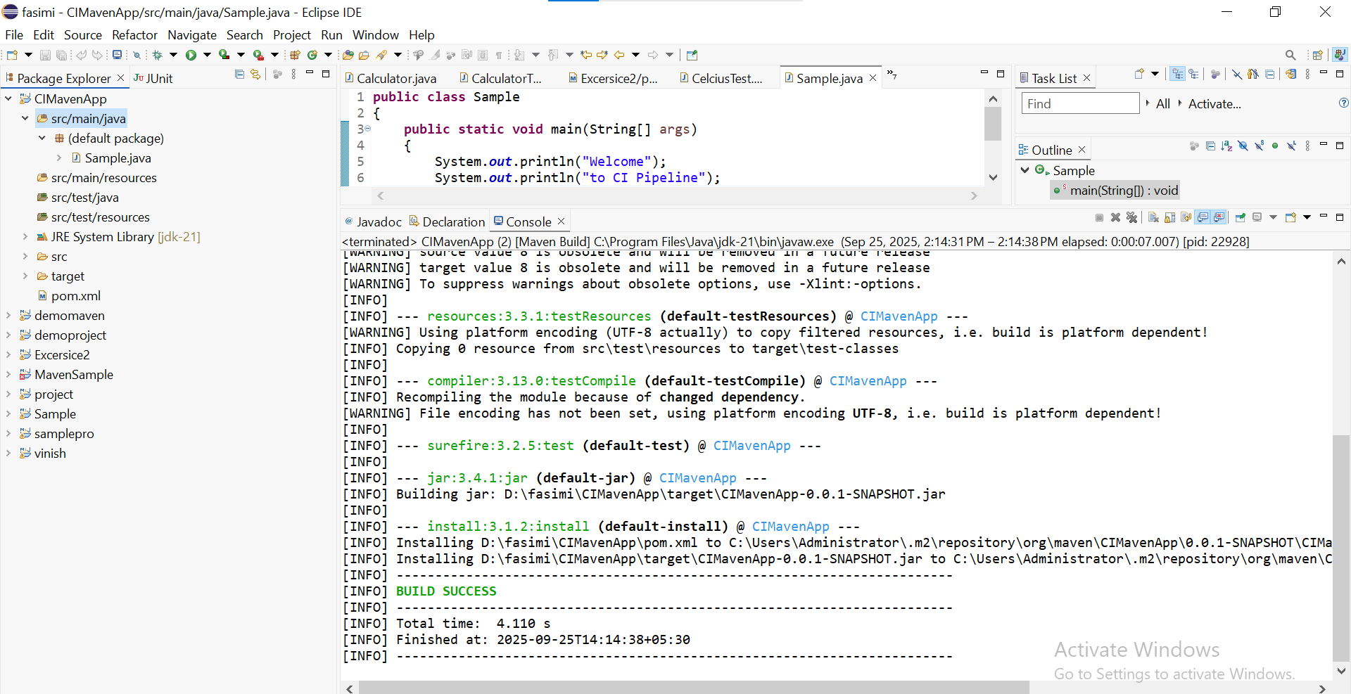

**Step 6:** Open the project folder and and right click and select git bash

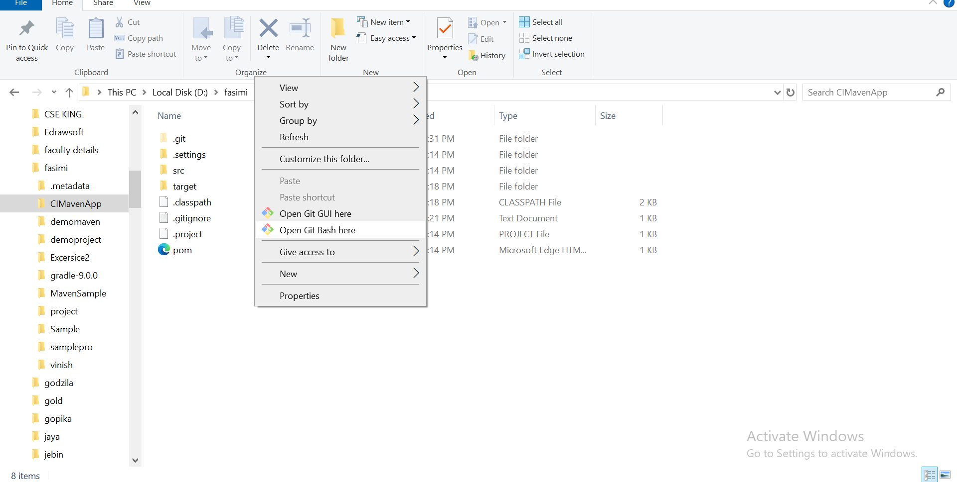

**Step 7:** Execute the following git commands to add the files to staging area and to commit

$ git init

$ ls -a

$ vi .gitignore and add the files .classpath, .settings

Save and exit the text file

$ git status

$ git add .

$ git commit -m “ Initial Message”

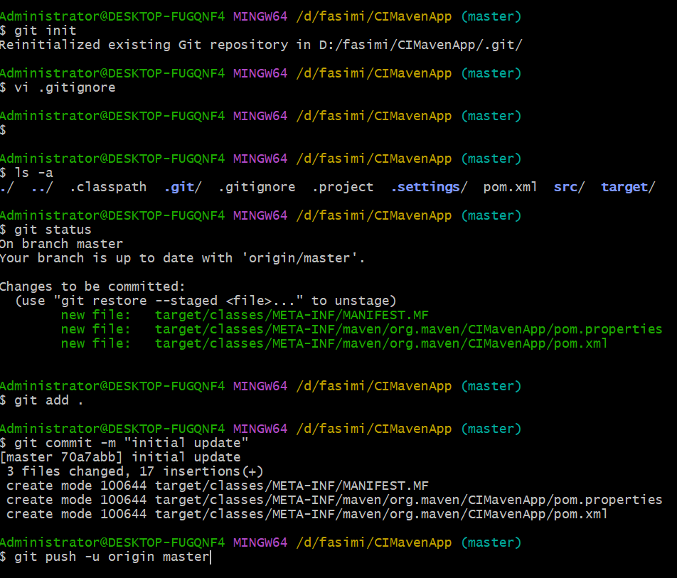

**Step 8:** Open the github account and create a new repository

**Step 9:** Execute the commands in git bash to clone the git with the created github repository and to push the files to github repository

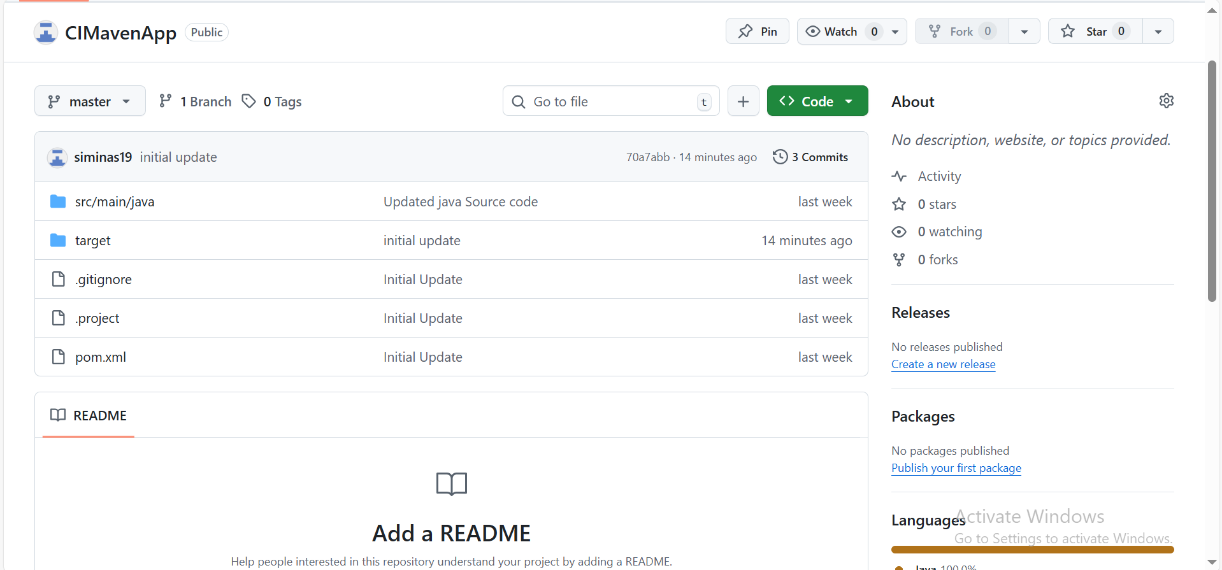

**Step 10:** Open Jenkins dashboard in browser by typing localhost:8080

**Step 11:** Create a free style project by clicking New Item and provide the name and click OK

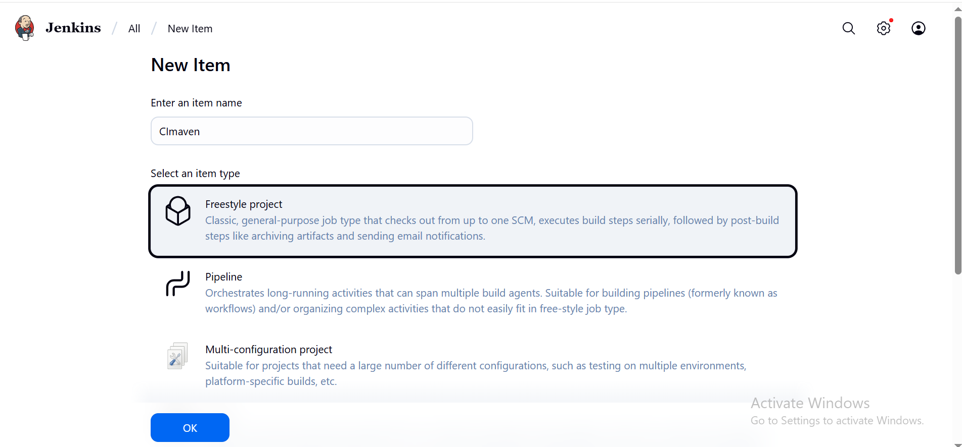

**Step 12:** Configure the project as follows:

Provide the description

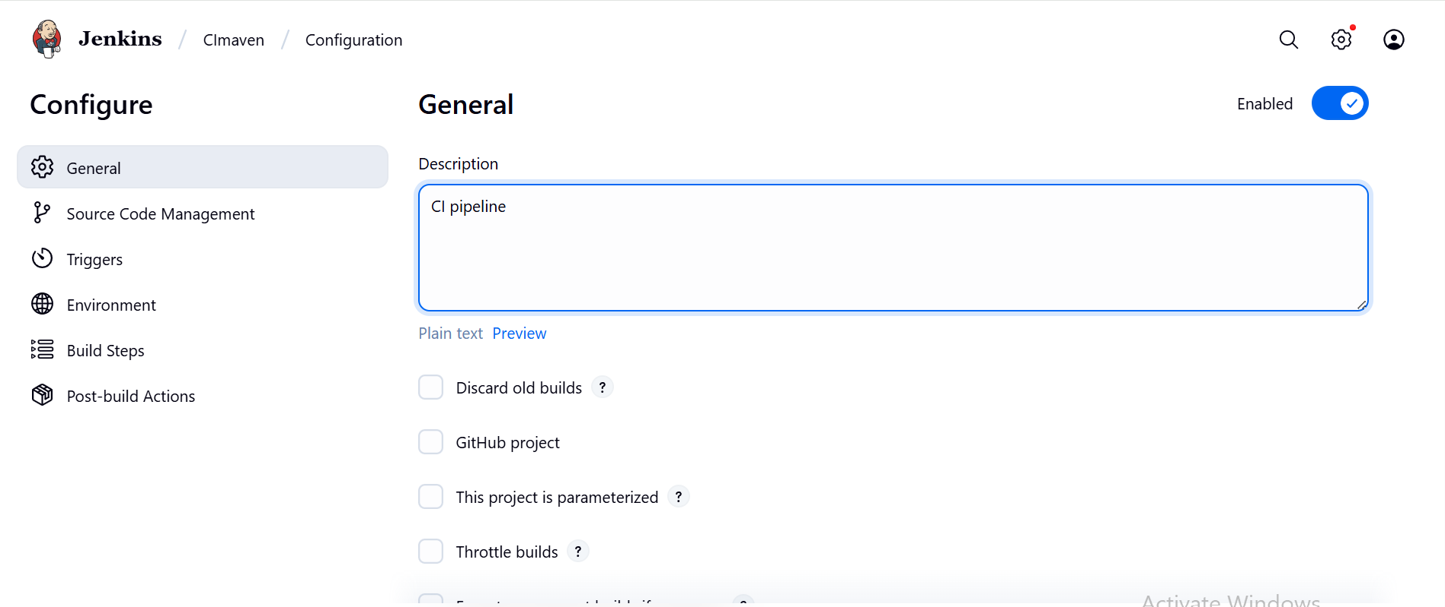

Select git as the source code management and paste the url of github repository

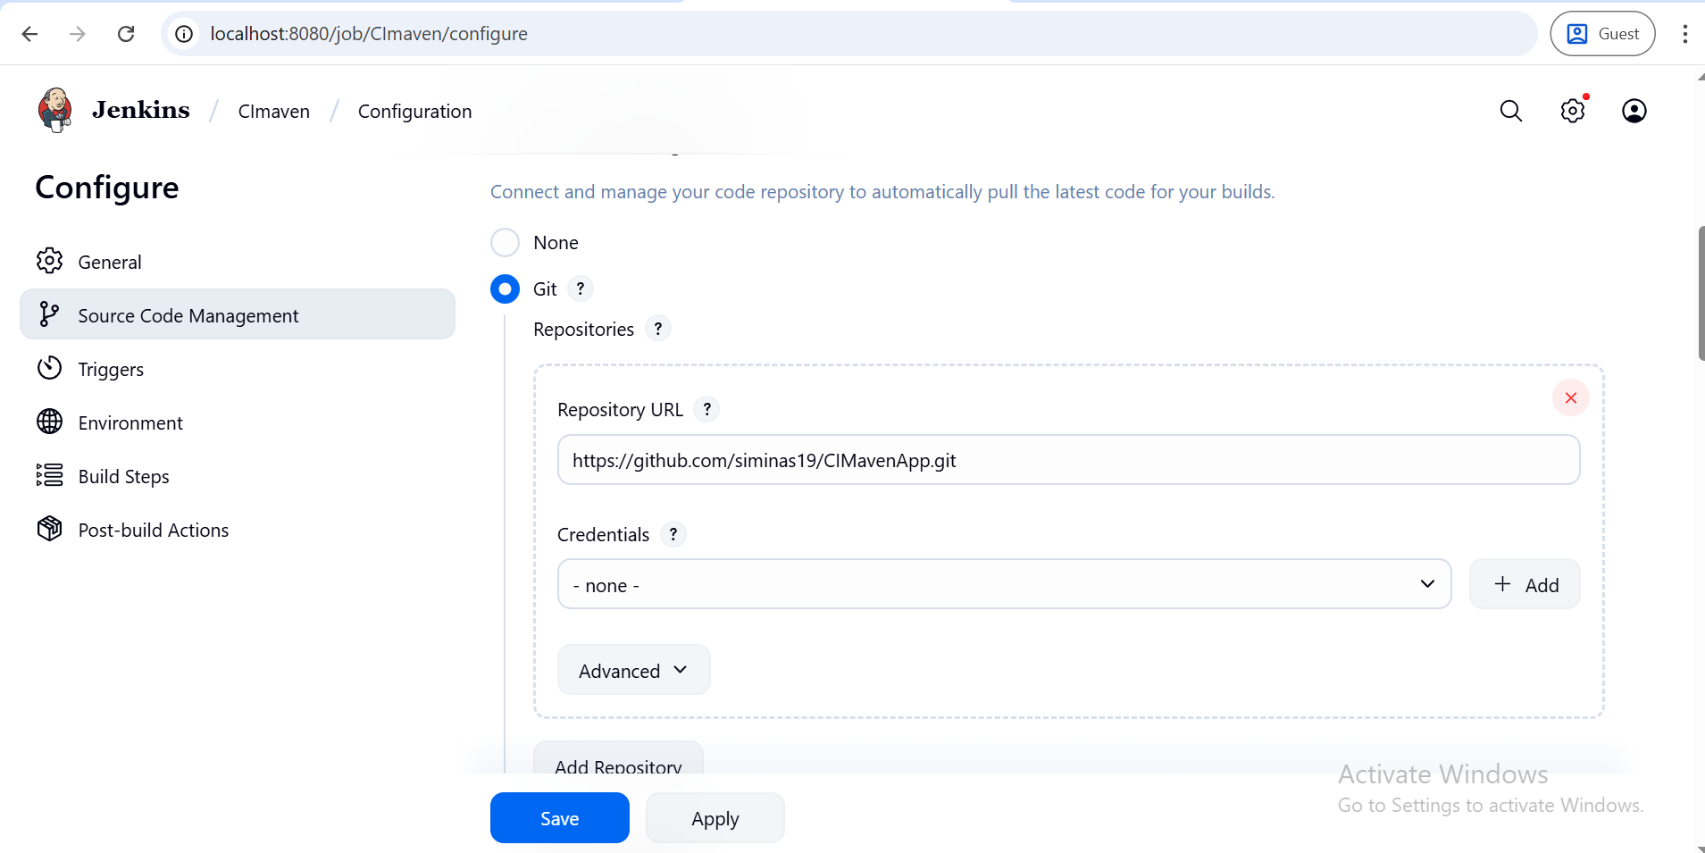

Select PollSCM for Building triggers and type the expression * * * * * to check the git for every minute for updation

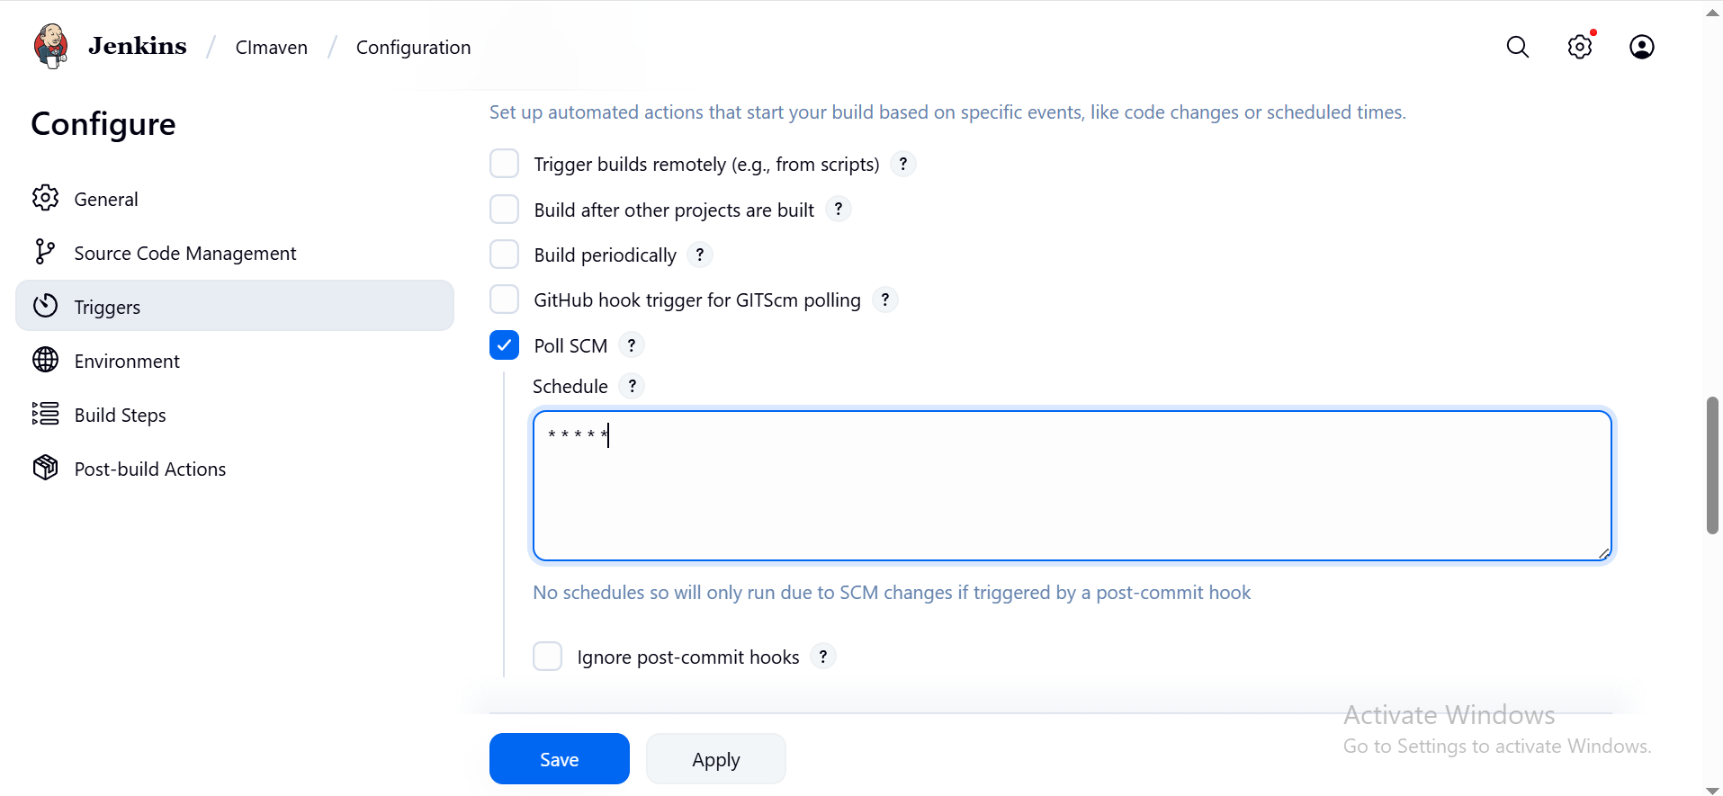

Select Executable Windows Batch Commands in Add Build Steps and type the following commands

cd src/main/java

javac Sample.java

java Sample

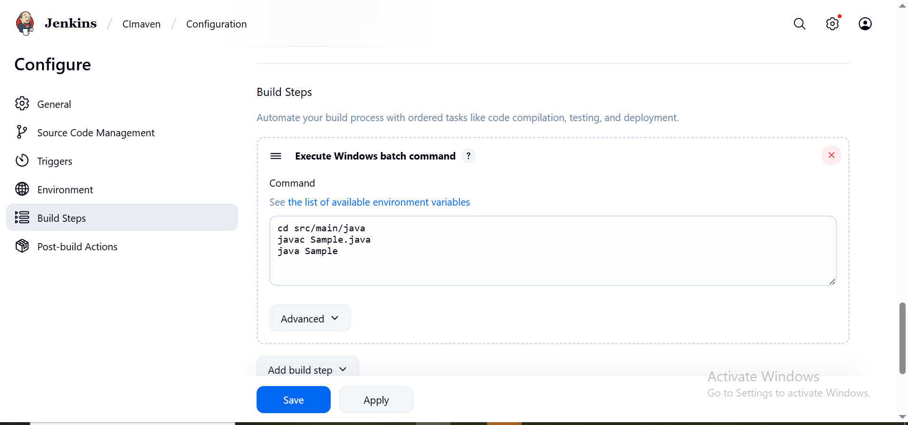

Click Apply and Save

**Step 13:** Click build now for instant build

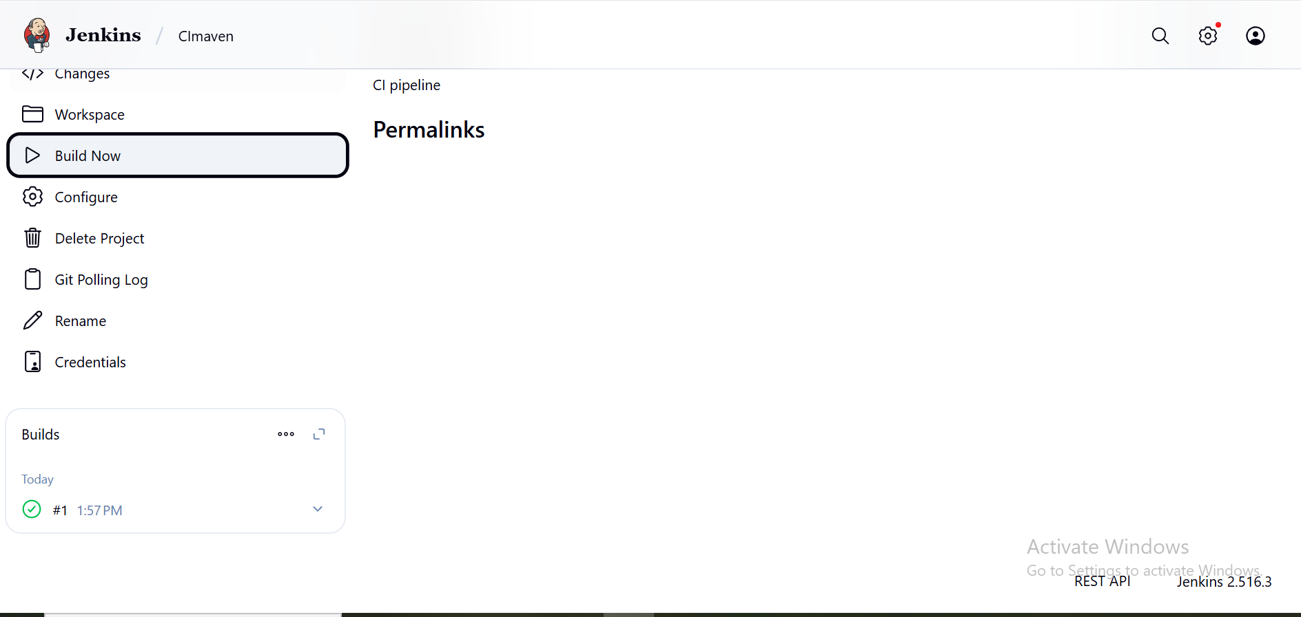

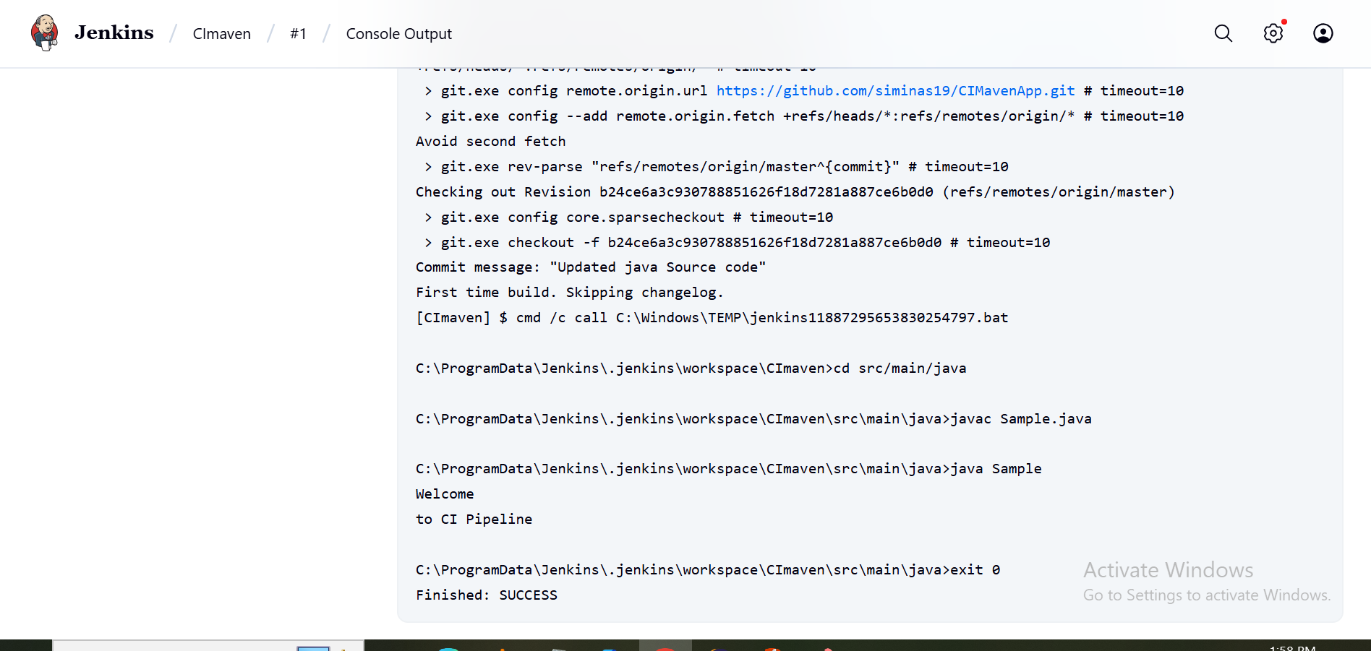

**Step 14:** Update the java file in Maven

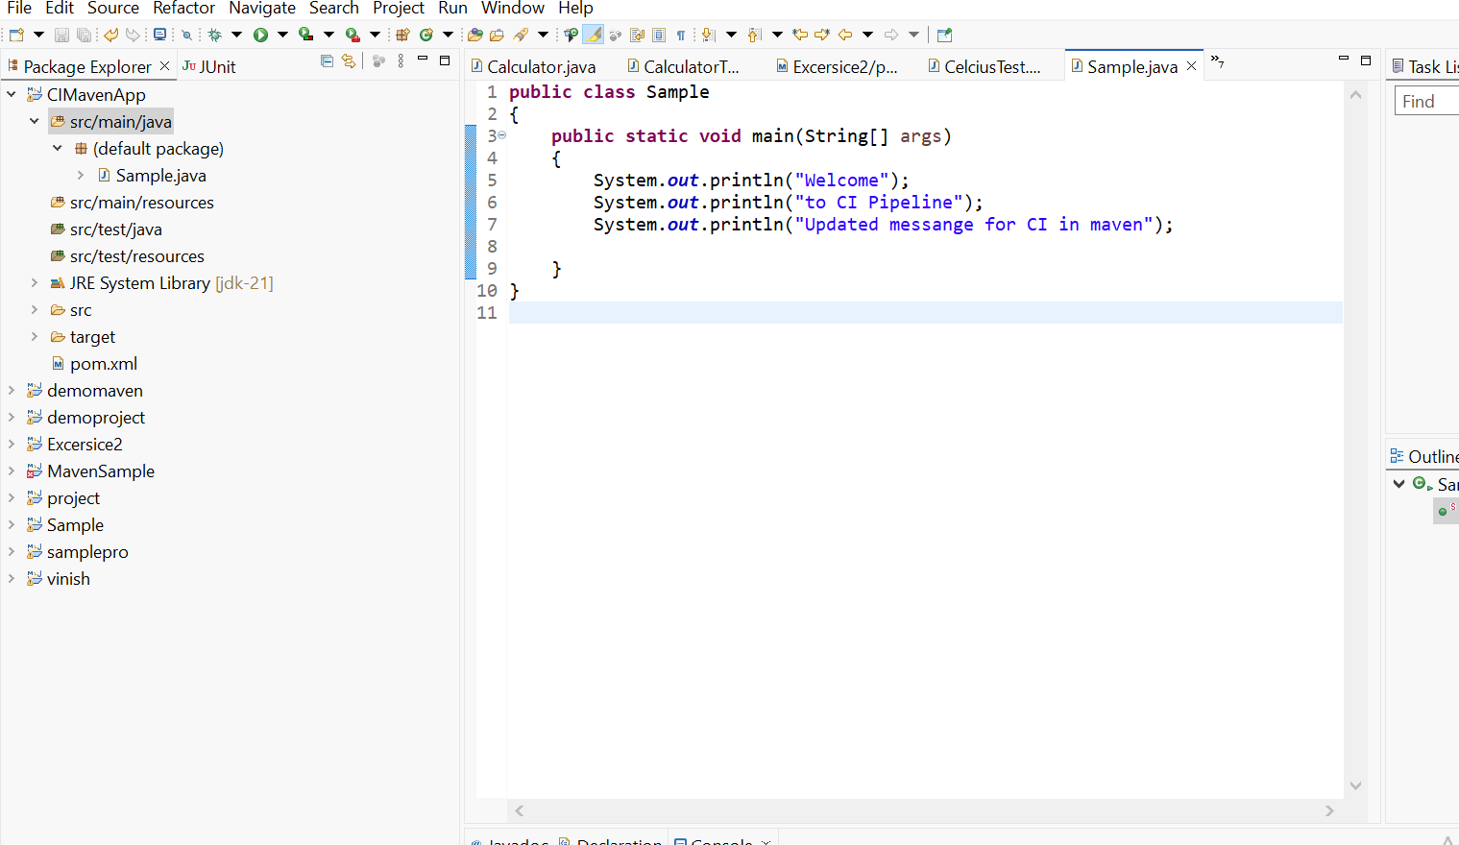

**Step 15:** Add the updated file contents to the staging area by the command and do the commit and push operation

$ git add .

$ git commit

$ git push

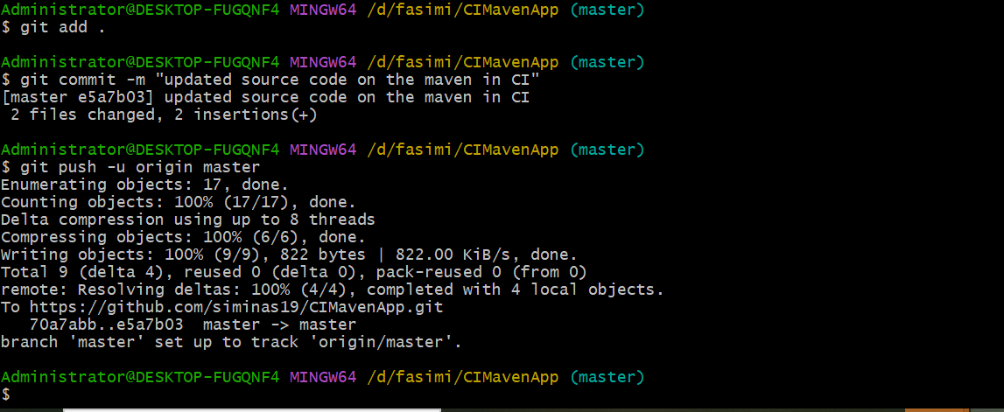

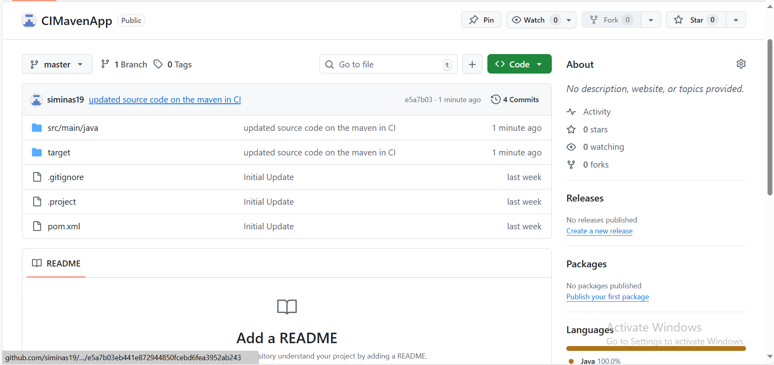

**Step 16:** Open Jenkins and wait for the build to see the updated output

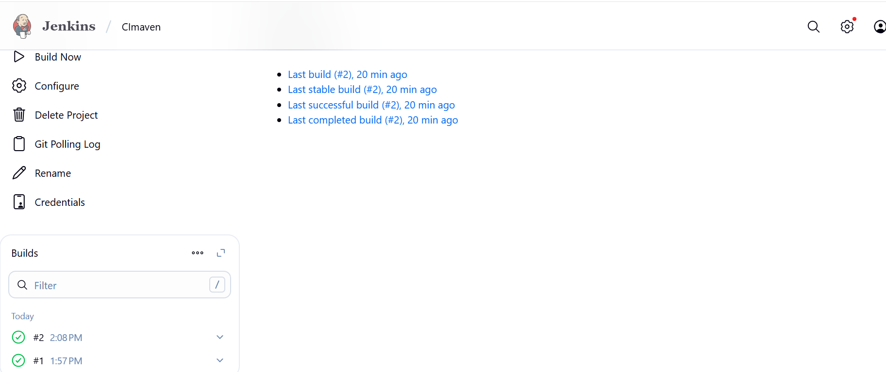

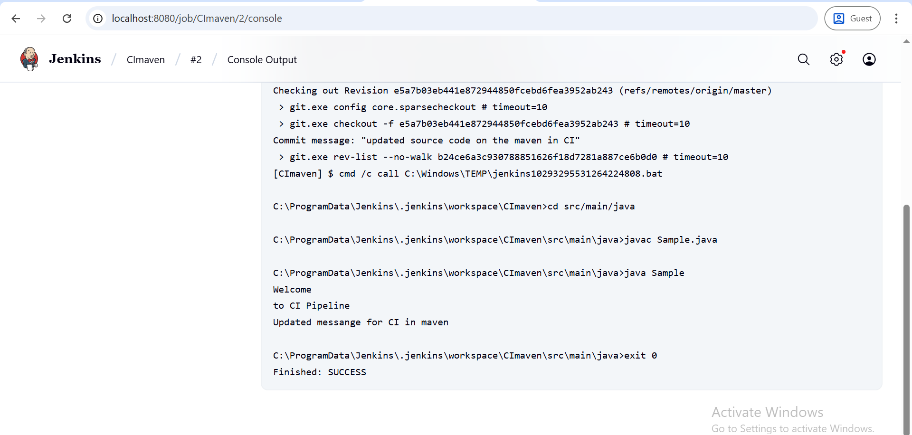

**RESULT:**

Thus the CI pipeline has been created successfully by connecting Maven, git and configuring Jenkins

**Ex.No.: 5 Create a CD pipeline in Jenkins and deploy in Cloud**

**AIM**:

To design and implement a Continuous Deployment (CD) pipeline using Jenkins that automates the build, test, and deployment of an application.

**PROCEDURE**:

**Stage 1: Creating Maven Web Application**

**Step 1:** Create a Maven Web Application by selecting File→ New → Maven Project

**Step 2:** Click Next (Do not select Create a Simple Application)

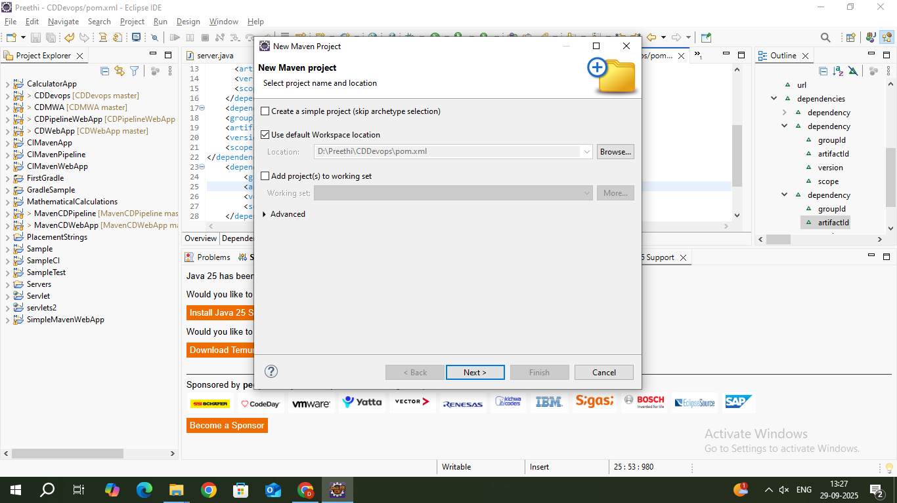

**Step 3:** Choose Internal in Catalog and select the Artifactid maven-archetype-webapps in the org.apache.maven.archetypes and click next.

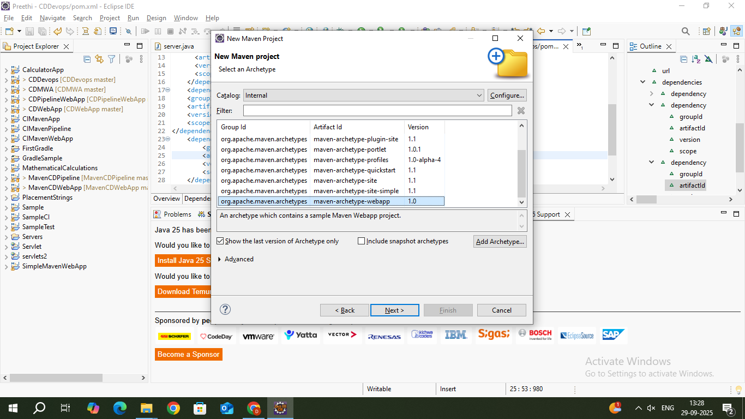

**Step 4:** Give the groupId and artifactId for the project and click Finish

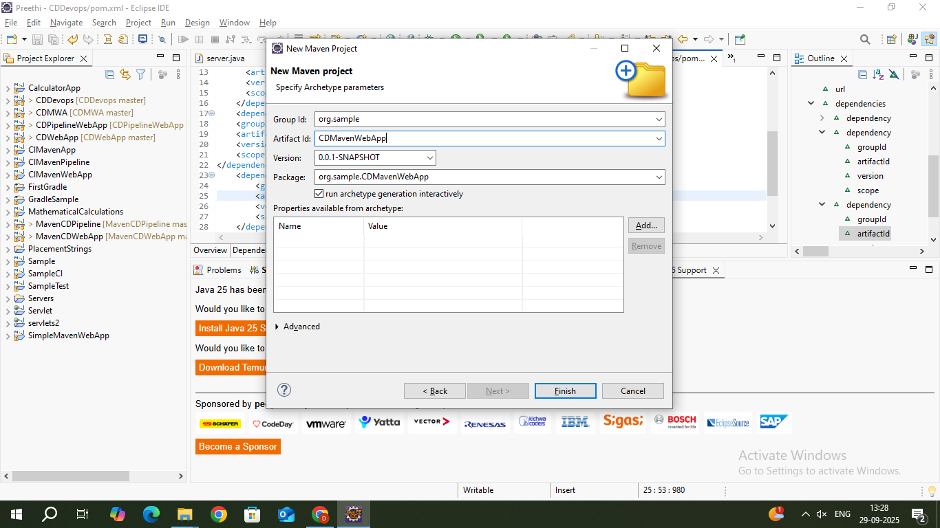

**Step 5:** Open the index.jsp file

**Step 6**: Update the file for the application

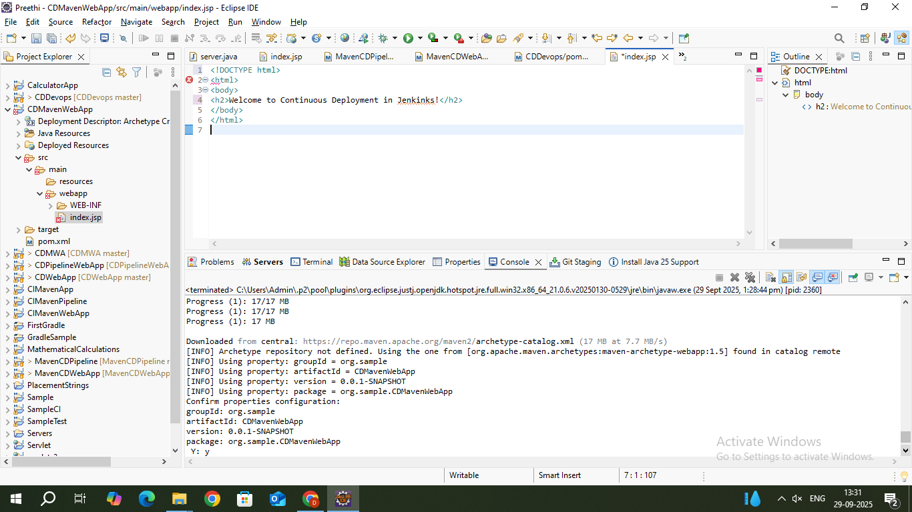

**Step 7**: Add the following dependencies in pom.xml file

<dependency>

<groupId>javax.servlet</groupId>

<artifactId>javax.servlet-api</artifactId>

<version>4.0.1</version>

<scope>provided</scope>

</dependency>

<dependency>

<groupId>jakarta.servlet</groupId>

<artifactId>jakarta.servlet-api</artifactId>

<version>6.0.0</version>

<scope>provided</scope>

</dependency>

**Step 8:** Right click inex.jsp file and click as run on server

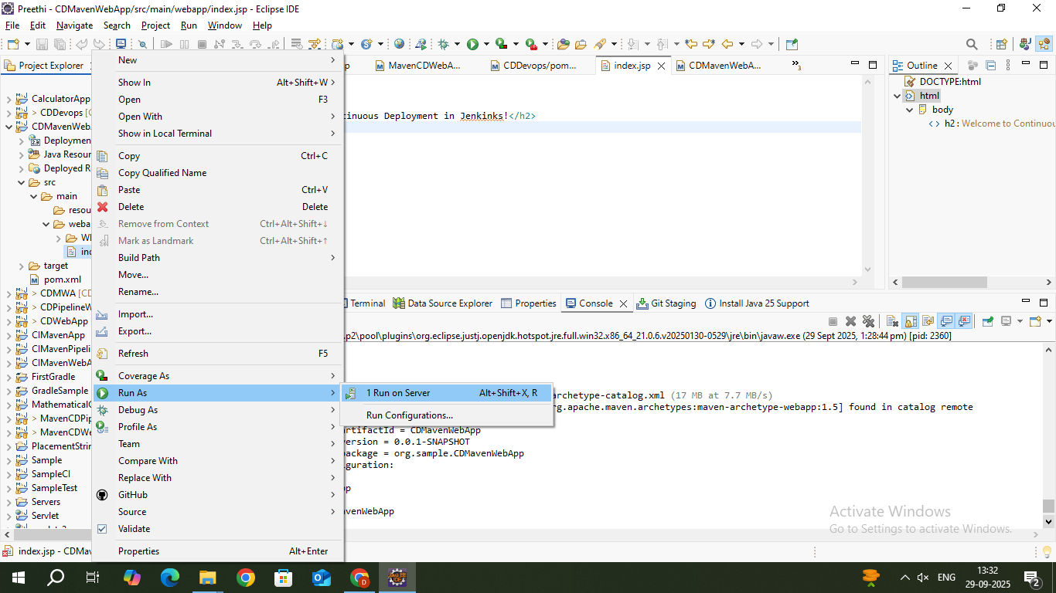

**Step 9:** Choose the server Apache Tomcat 10.1 and click Finish. The application is deployed on tomcat server

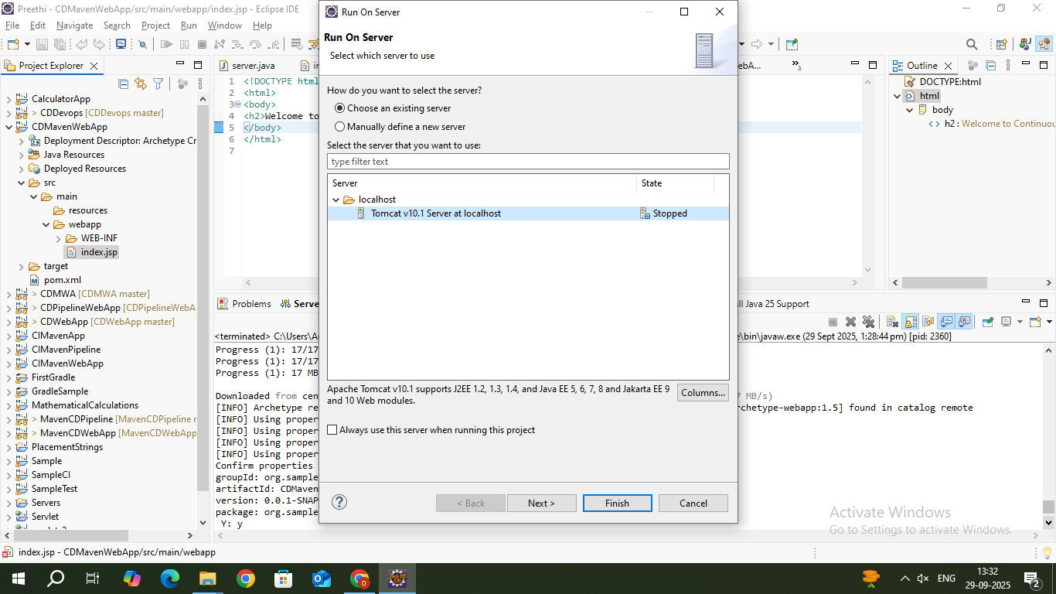

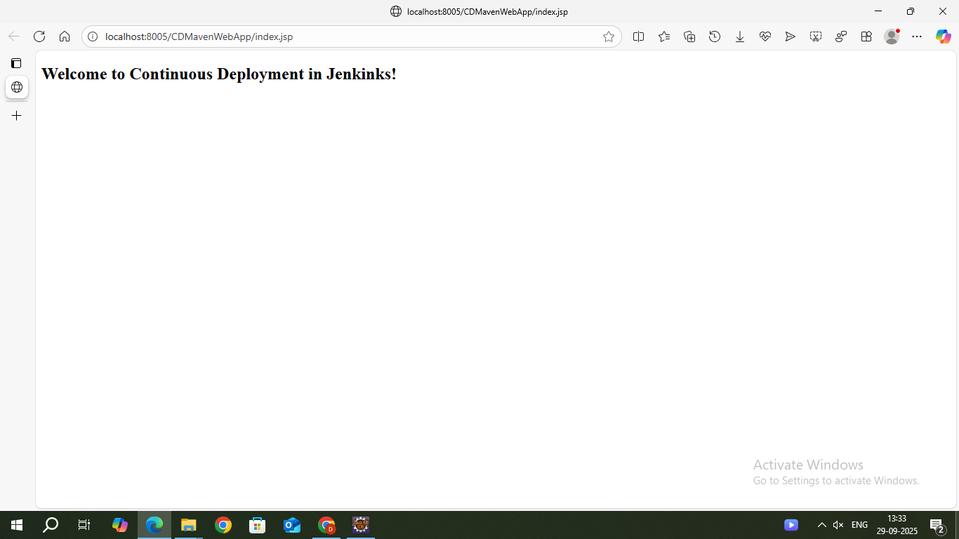

**Stage 2: Pushing the Web application to github**

**Step 1:** Open Github and create a repository in the name same as the artifactId of maven project

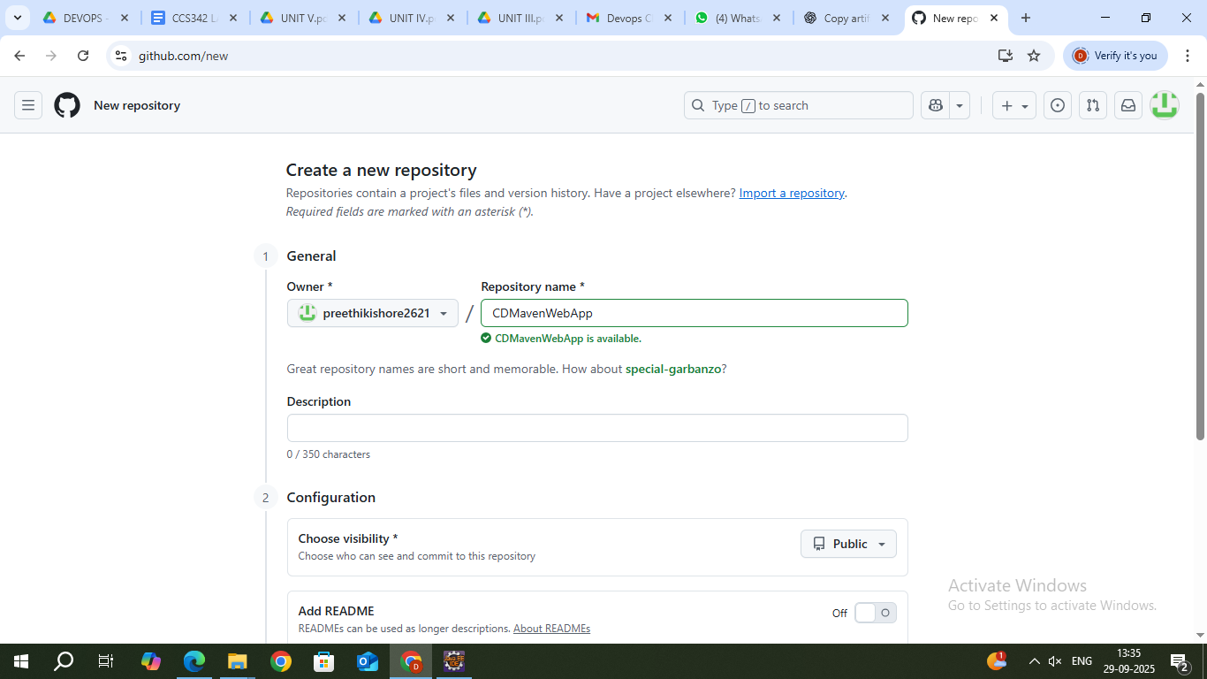

**Step 2:** Open the account settings and move on to developer settings and choose Personalized tokens(Classic)

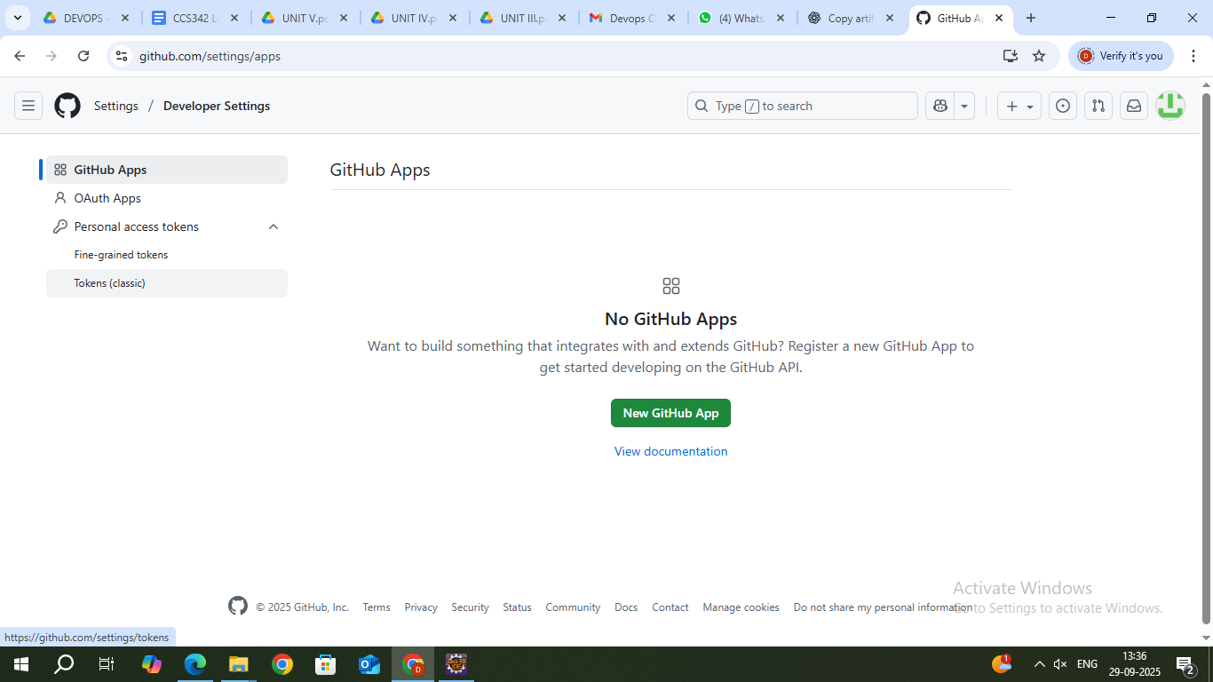

**Step 3:** Click on generate token and choose token classic

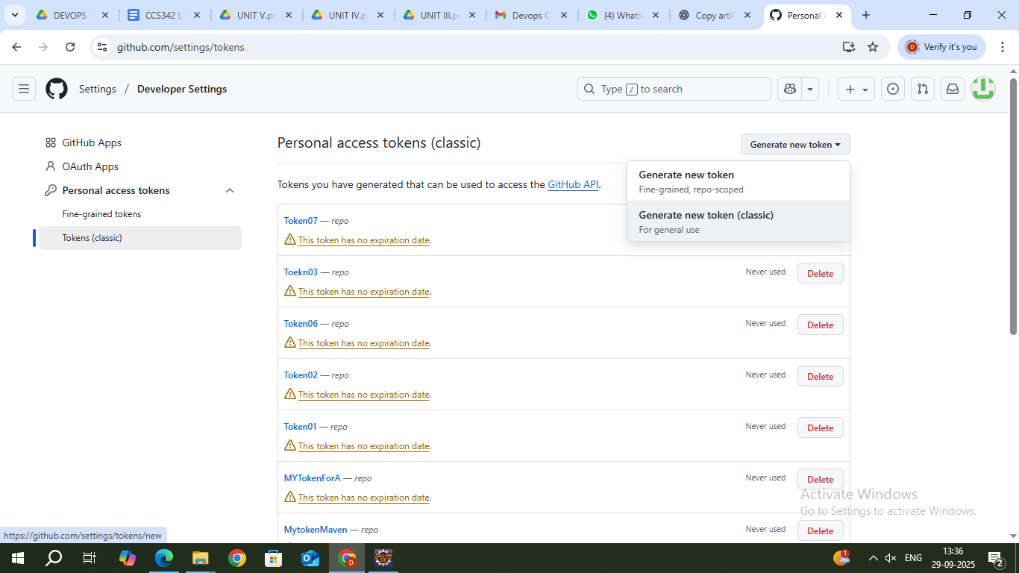

**Step 4:** Provide a suitable name for the token and choose the expiration as no expiration and provide accessible privileges for the repository from the third party by selecting repo checkbox and click generate token

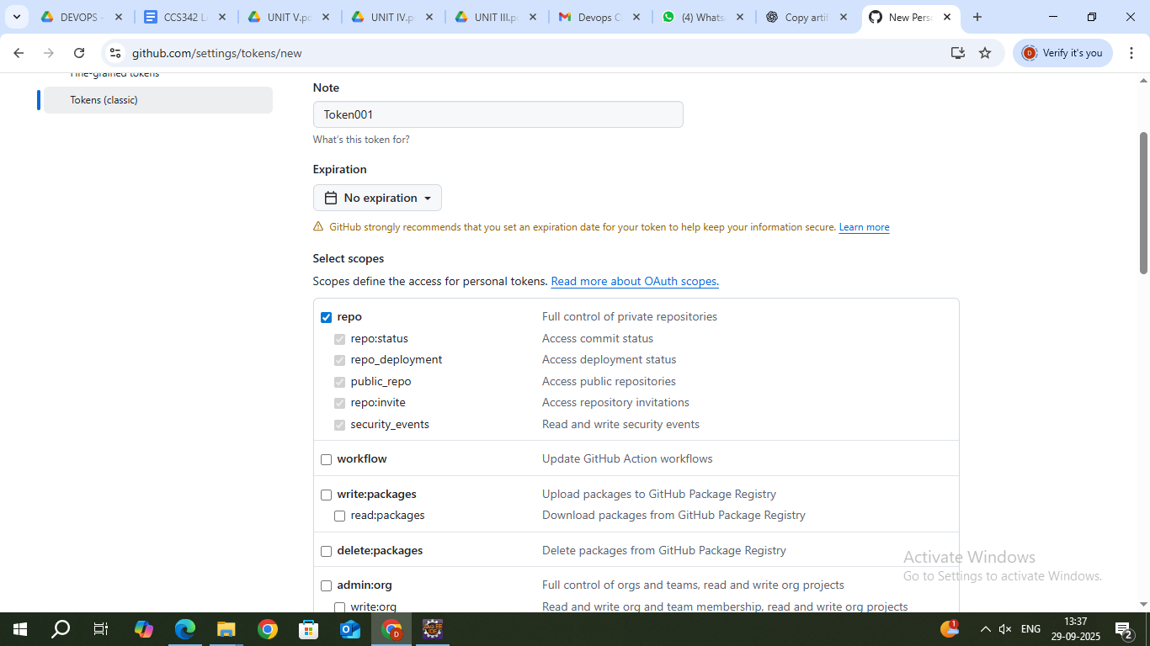

**Step 5:** Copy the token password for further use.

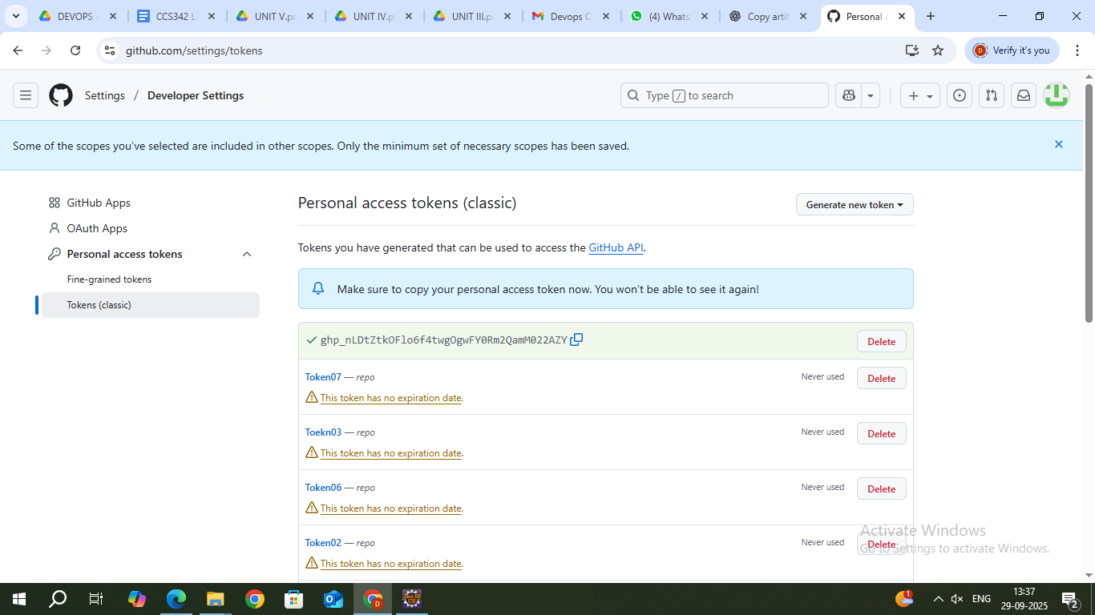

**Step 6:** Open Eclipse IDE and right click the project and select Team → Share project

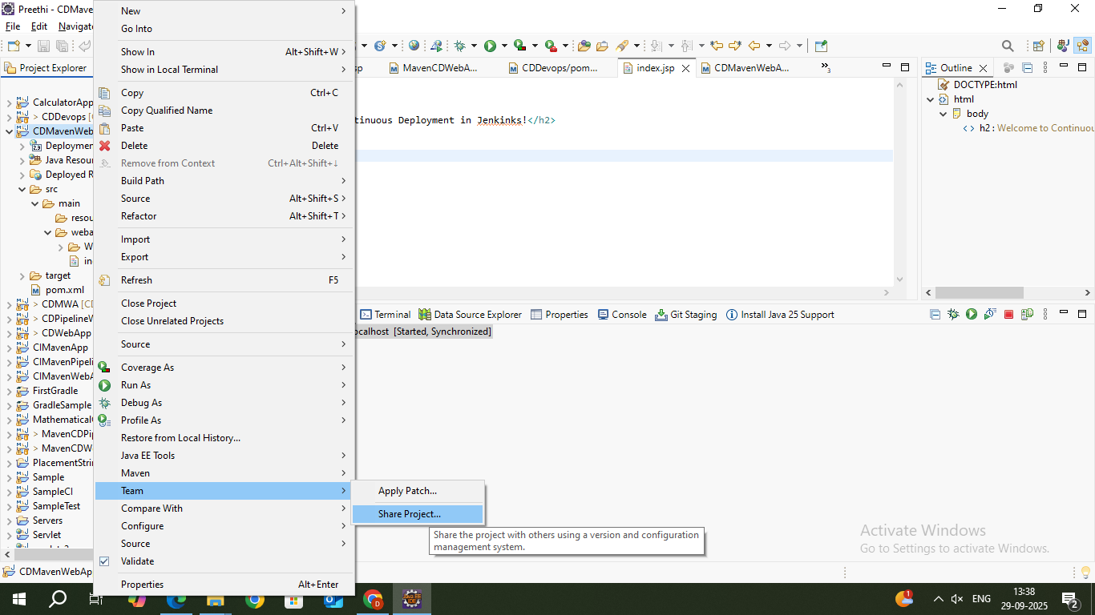

**Step 7:** Configure the Git repository by clicking on the check box for Use or create repository in parent folder of project and choose our project and click create repository to make as git and click Finish to create the master branch

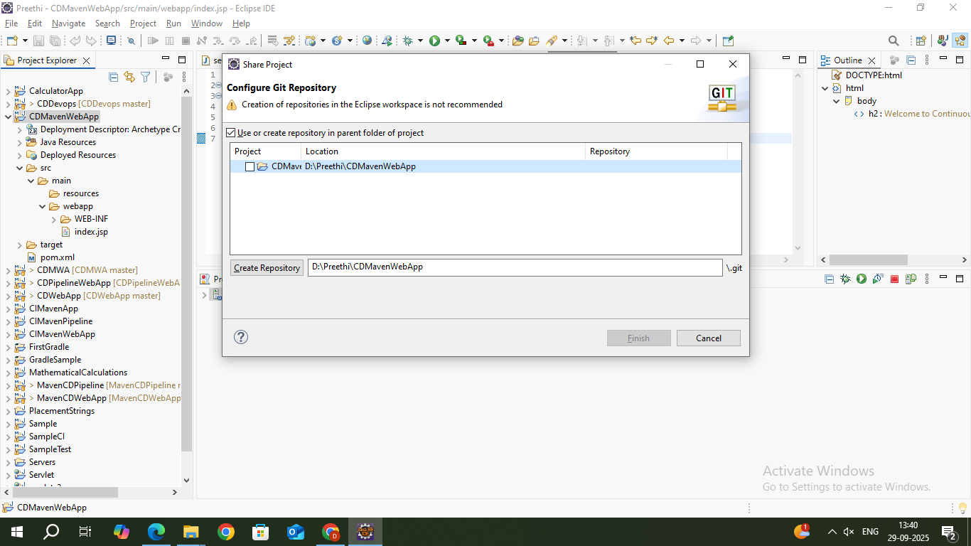

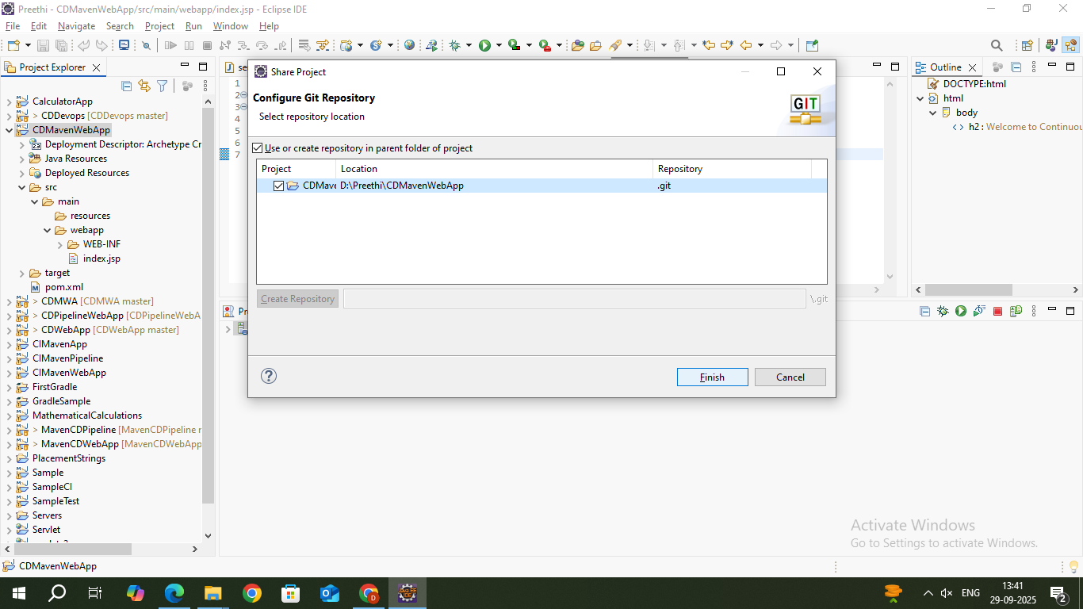

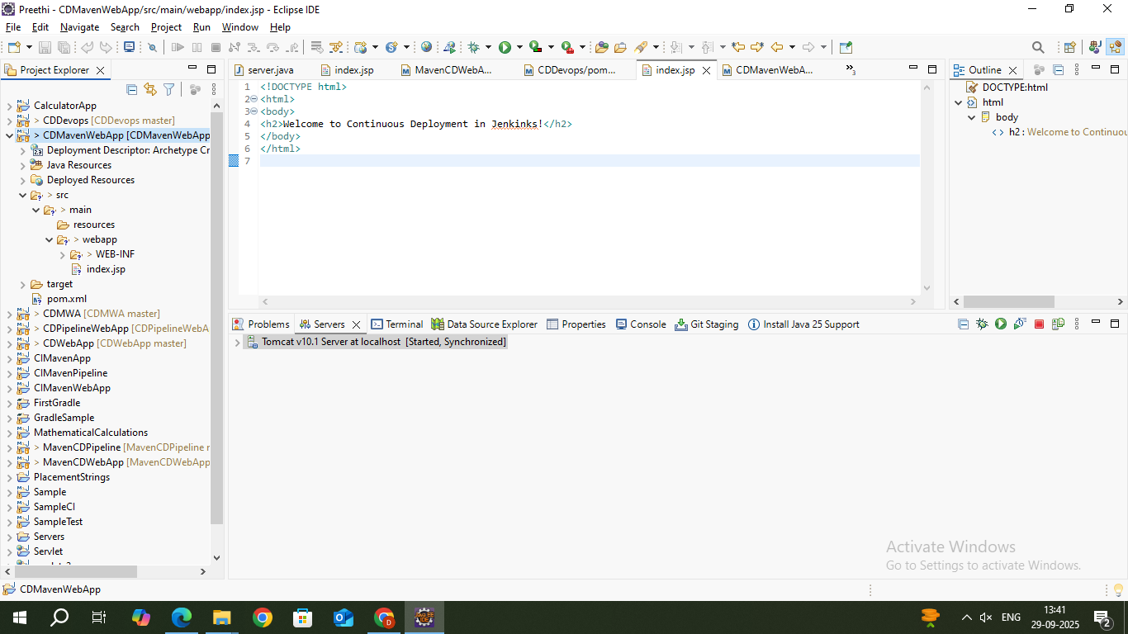**Step 8:** Right click the project again and choose Team → Commit

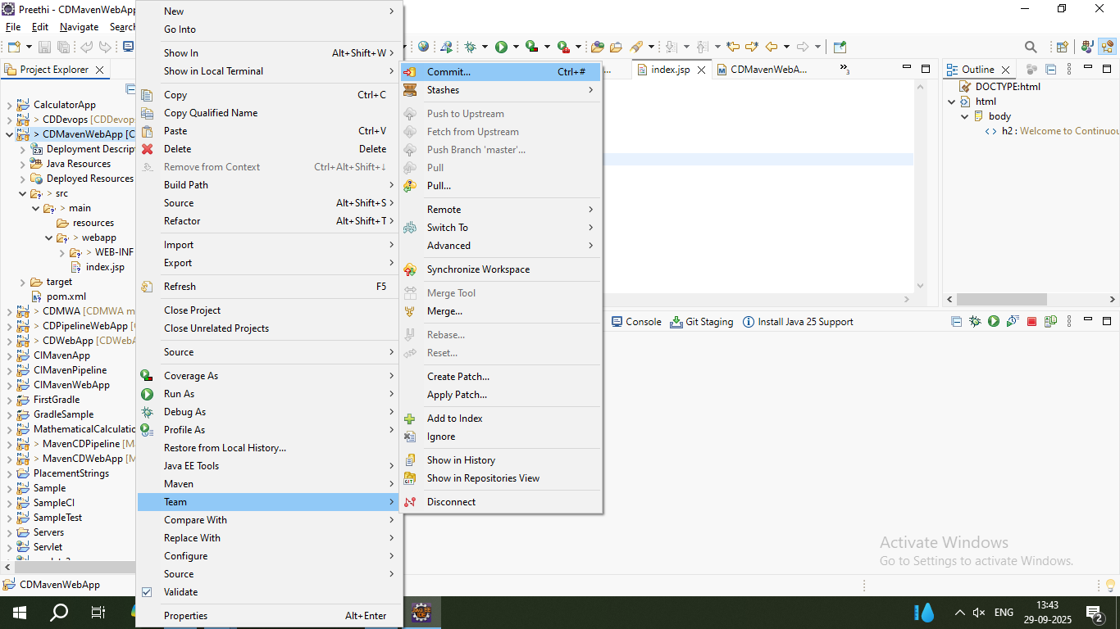

**Step 9:** Drag the files index.jsp and pom.xml from the Unstage changes to Staged Changes and Enter a commit message and provide the github account details of Author and the Committer and click Commit and Push

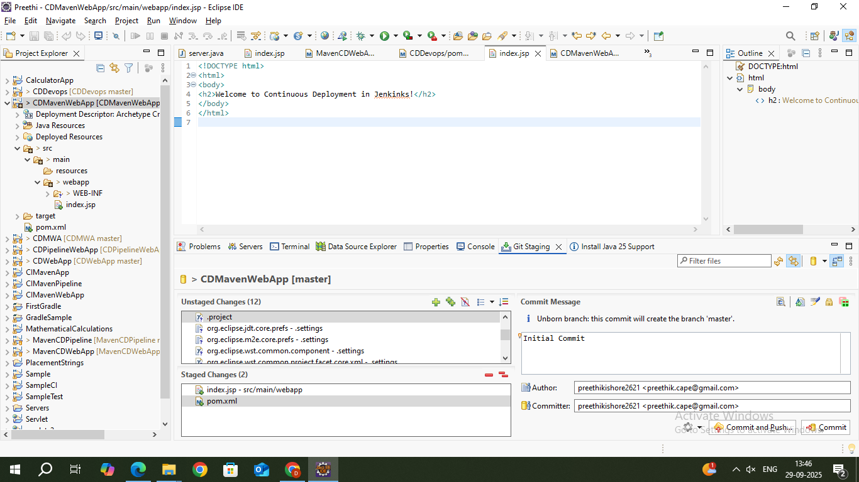

**Step 10:** Now click Push Head to configure the destination git repository

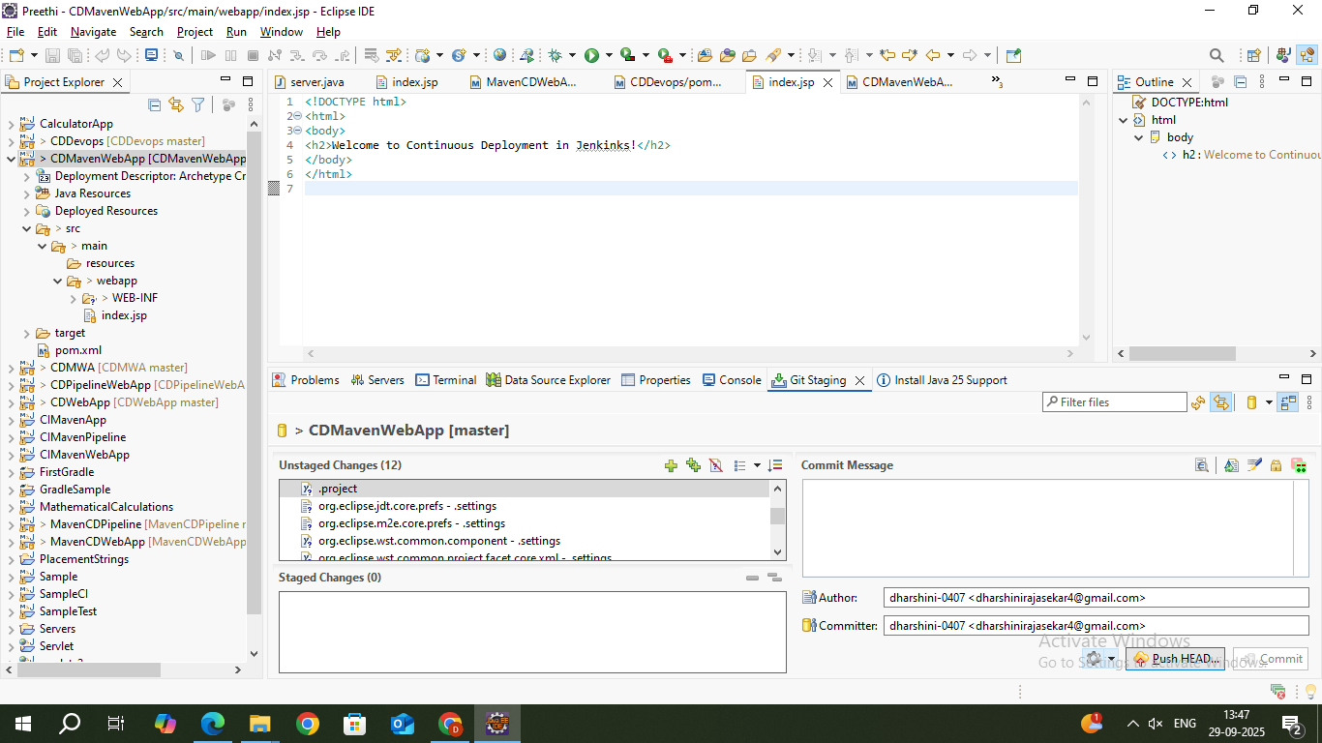

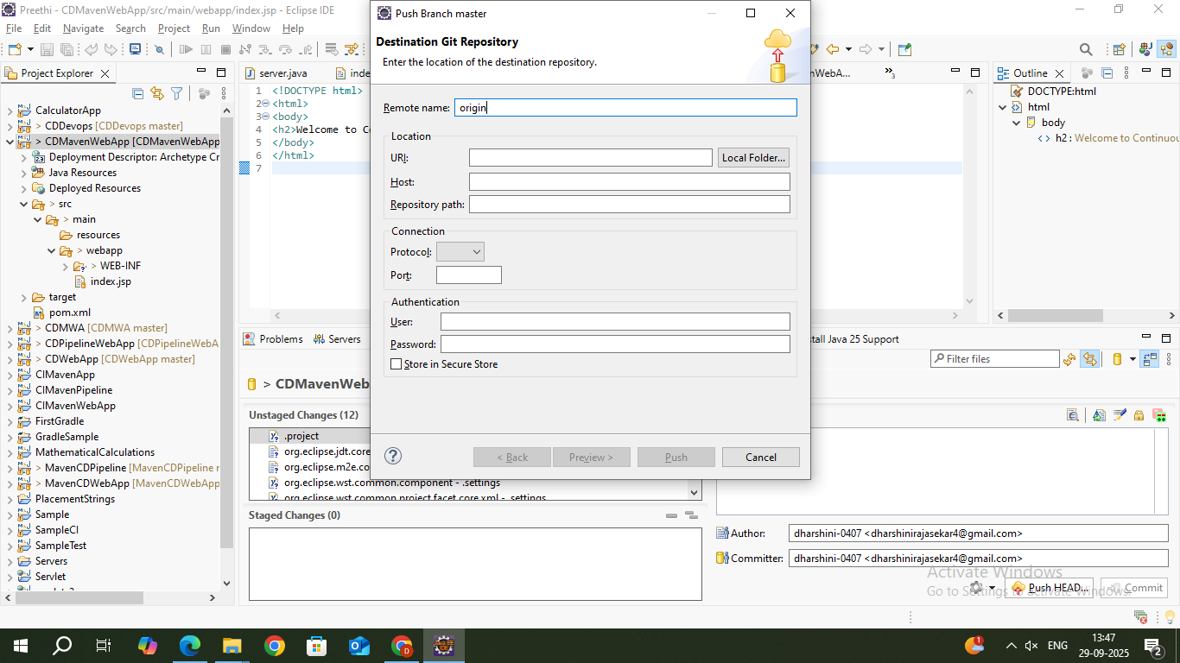

**Step 11:** Copy the url of the github repository and paste it in the url and provide the authentication credentials and click preview

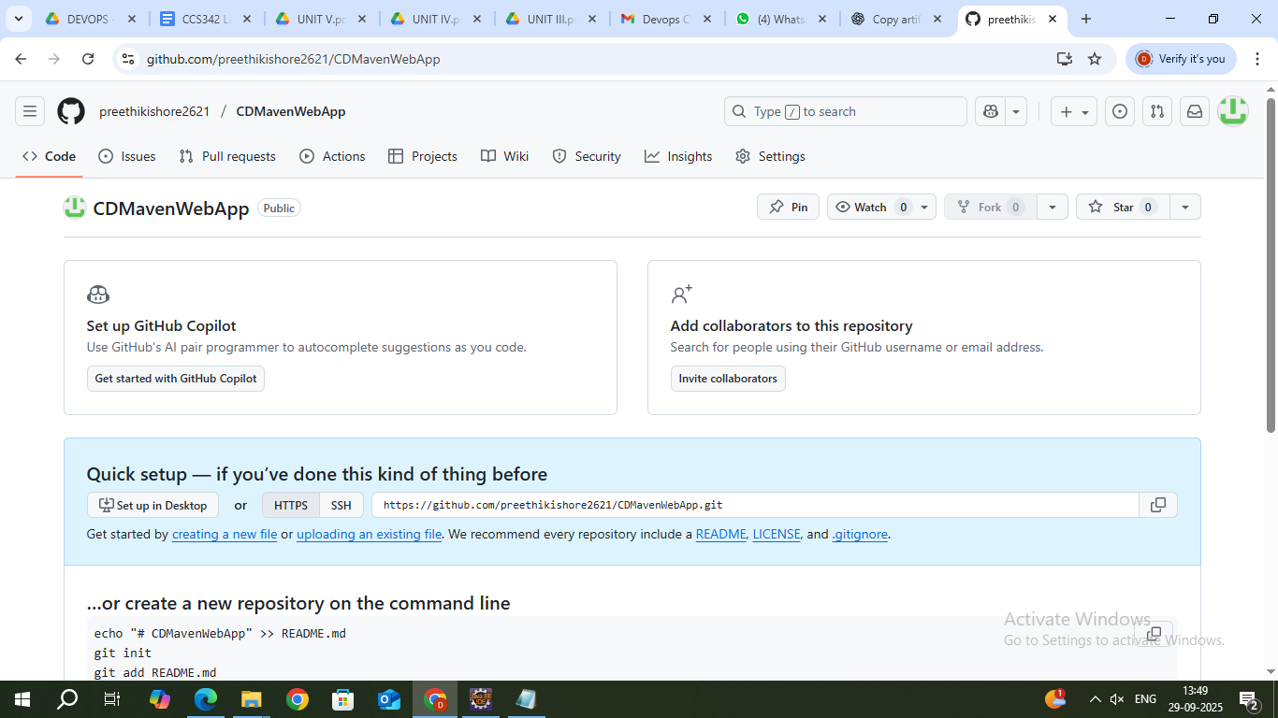

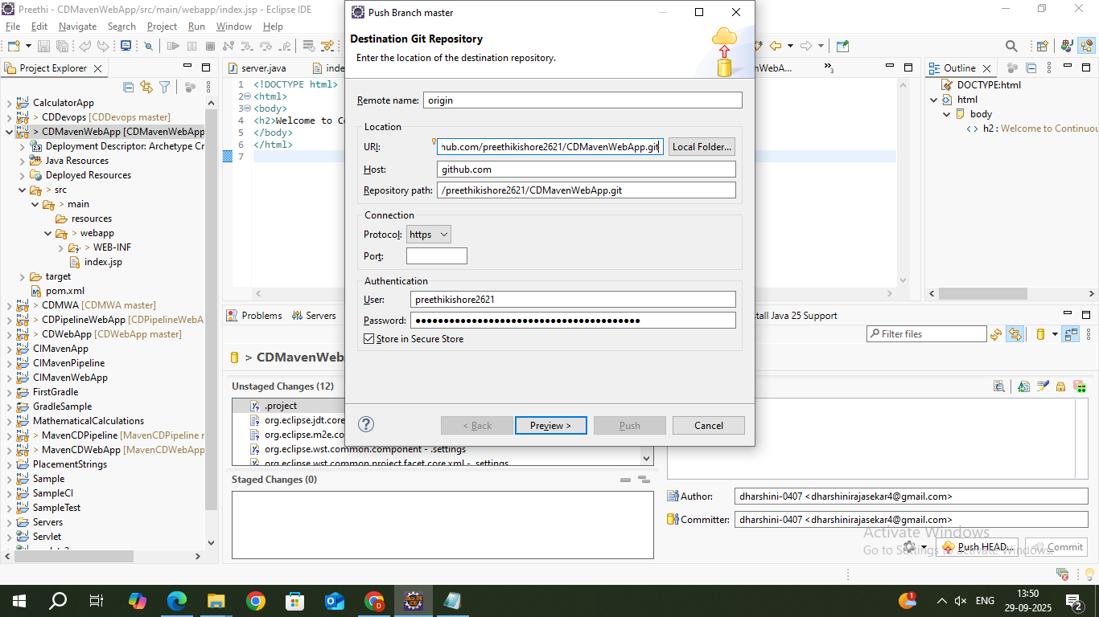

**Step 12:** Push the branch to remote by selecting master and click preview

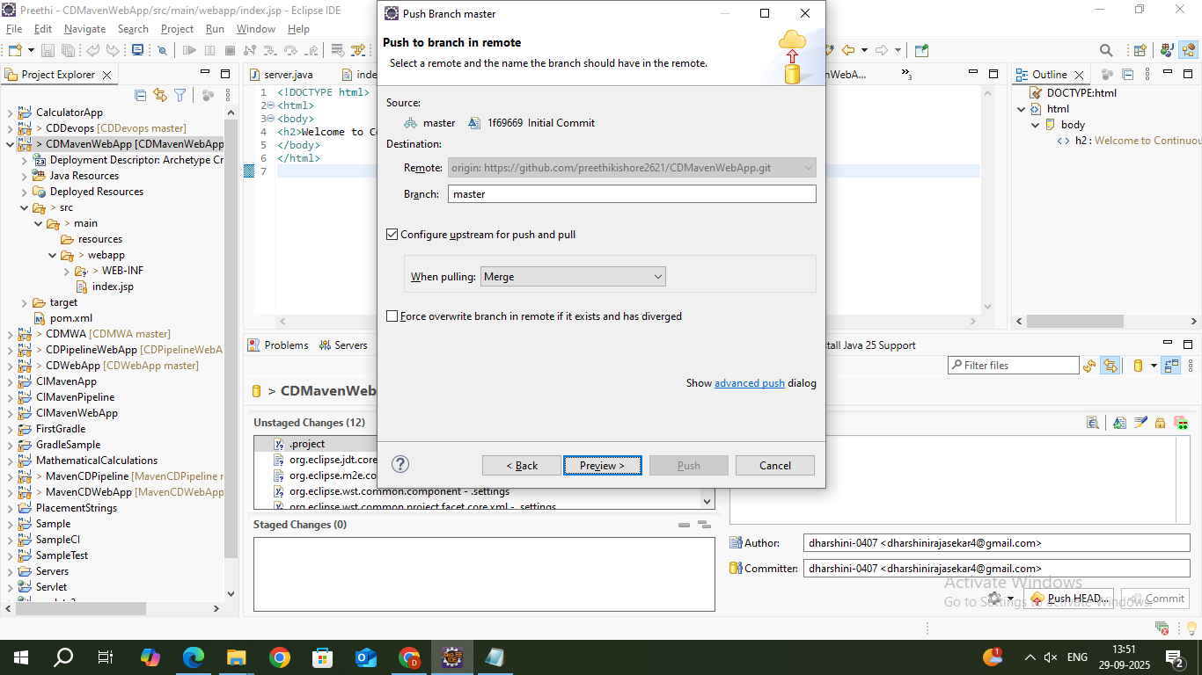

**Step 13:** Push the branch to remote by selecting master and click previewthe user of github account and provide the token password and check the Store in Secure Store and finish by login

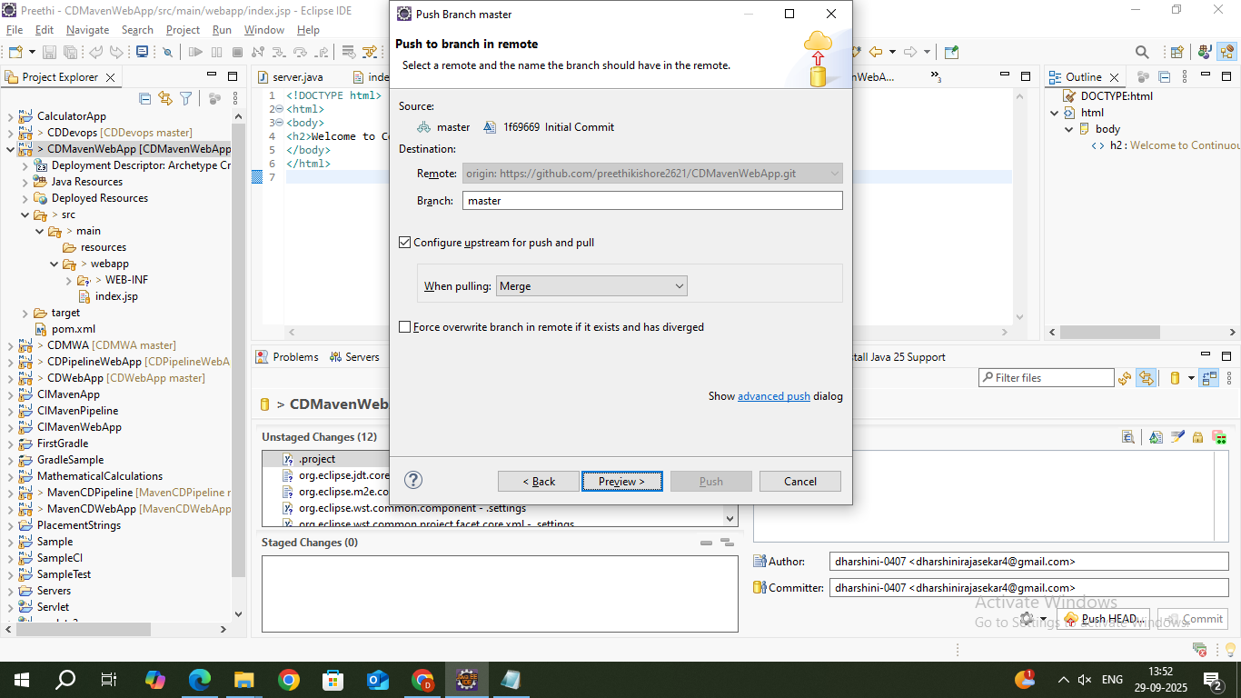

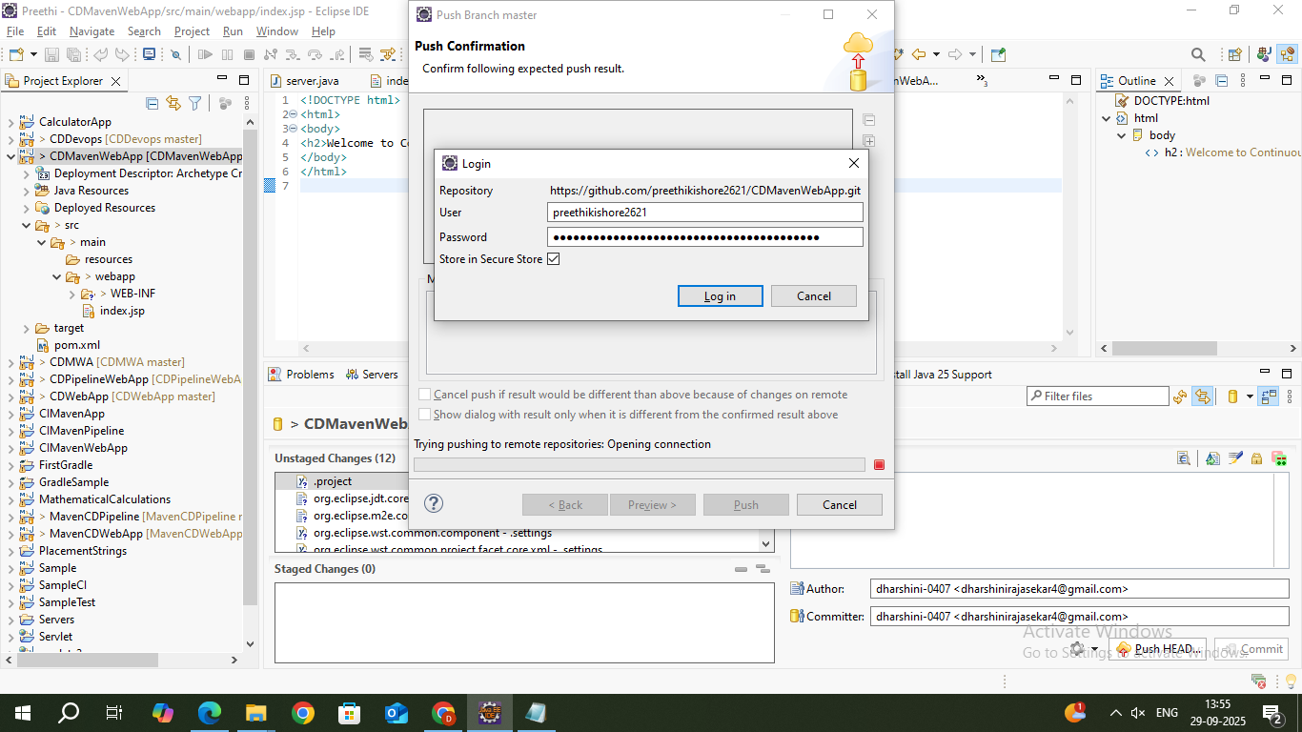

**Step 14:** Click push and again provide the login credentials same as previous step and close the dialog box

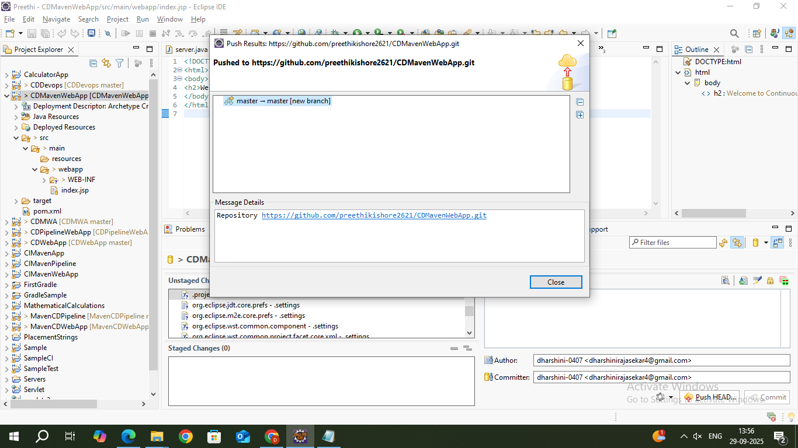

**Step 15:** Open github repository and refresh to see the changes

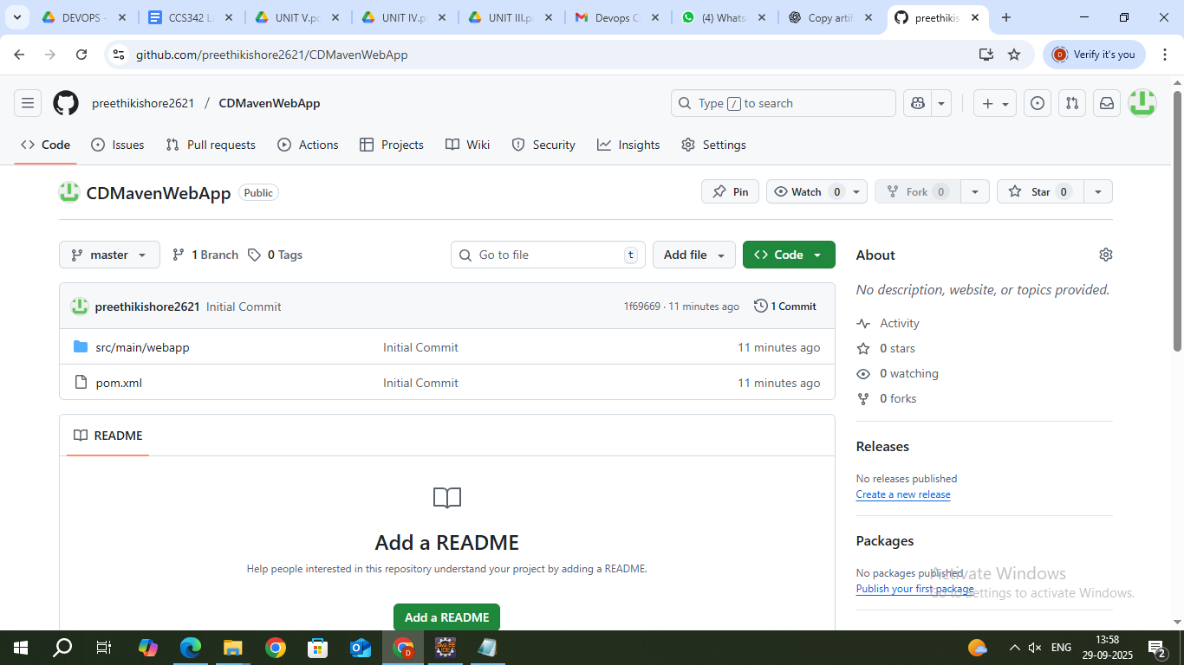

**Stage 3: Configure the Application in github and build in Jenkins**

**Step 1:** Open jenkins service

**Step 2:** Create a new free style project by selecting New Item and give the project name as same as artifactId

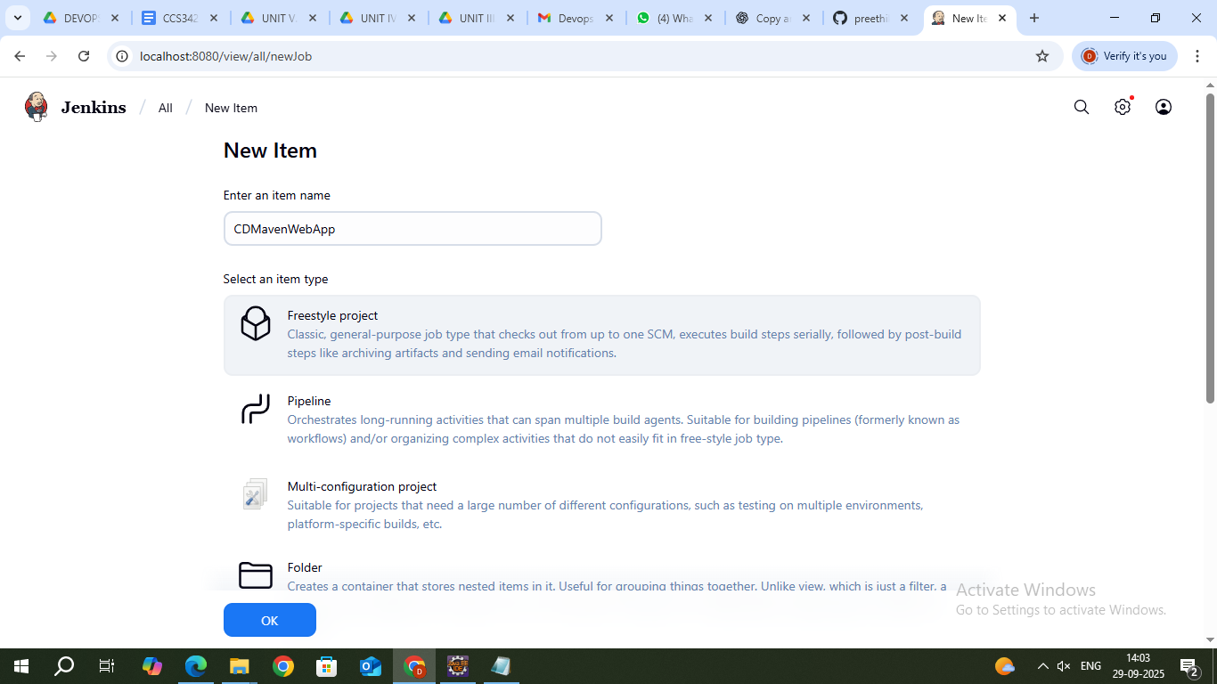

**Step 3:** Configure the project as follows

1. Type the suitable Description

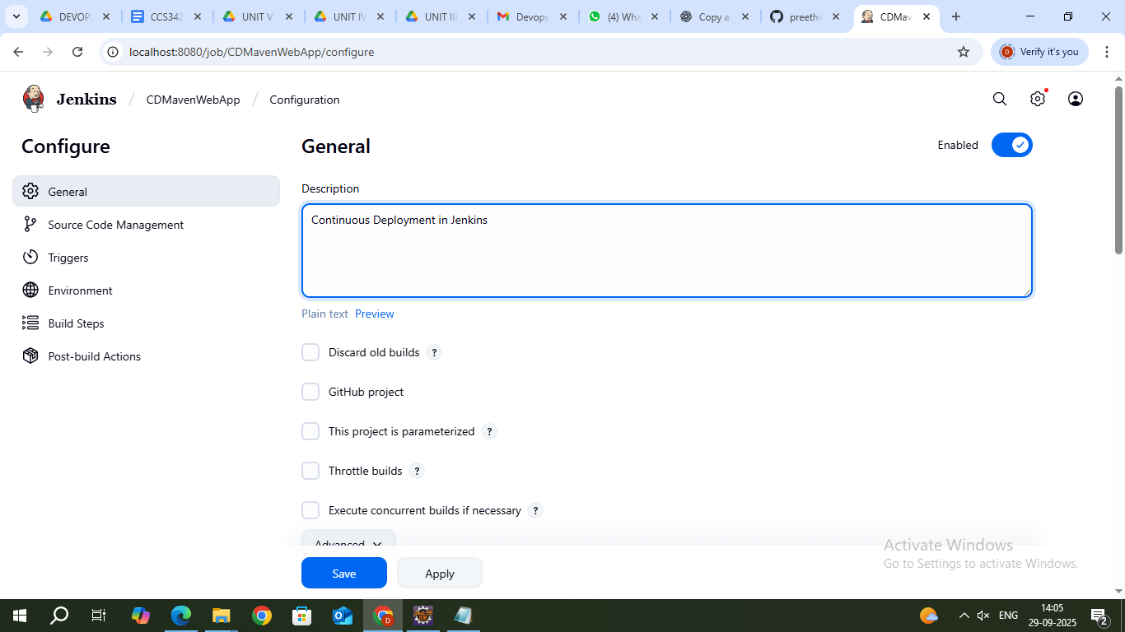

1. Choose the Source Code Management as Git and paste the url of repository and select the master as branch

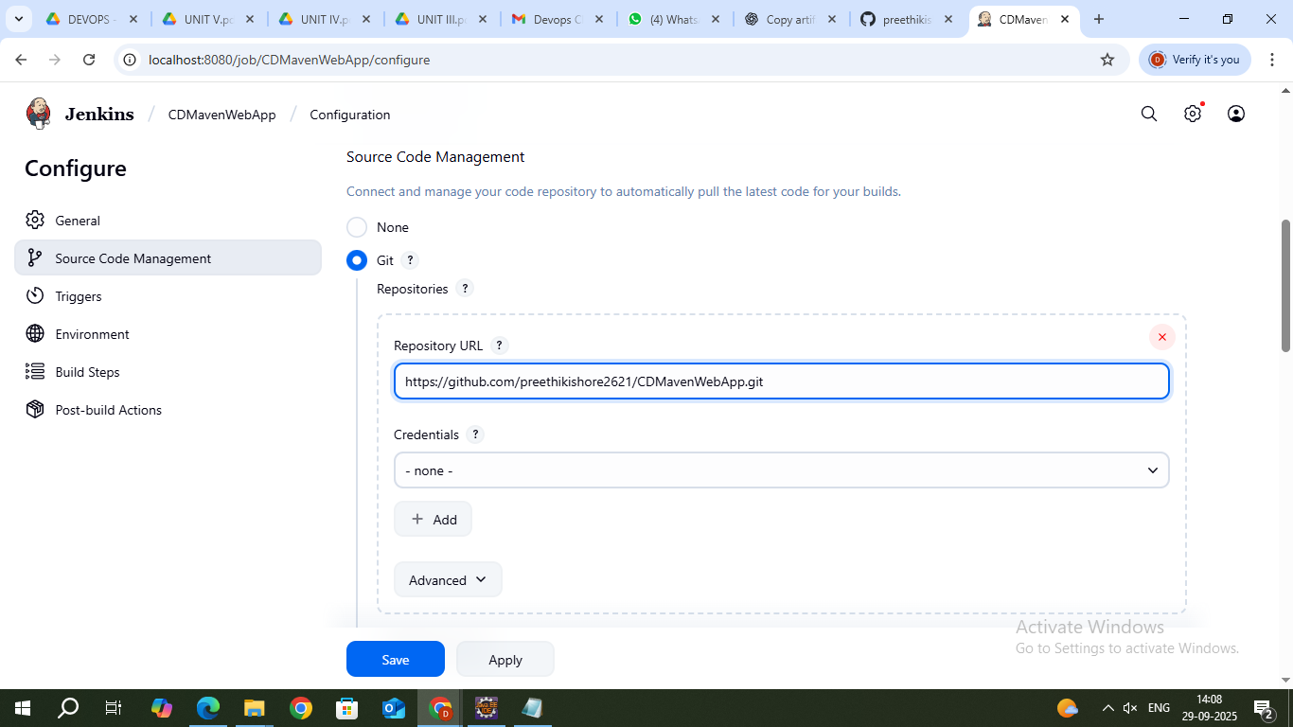

1. In Add Build Steps Choose Invoke top-level Maven targets

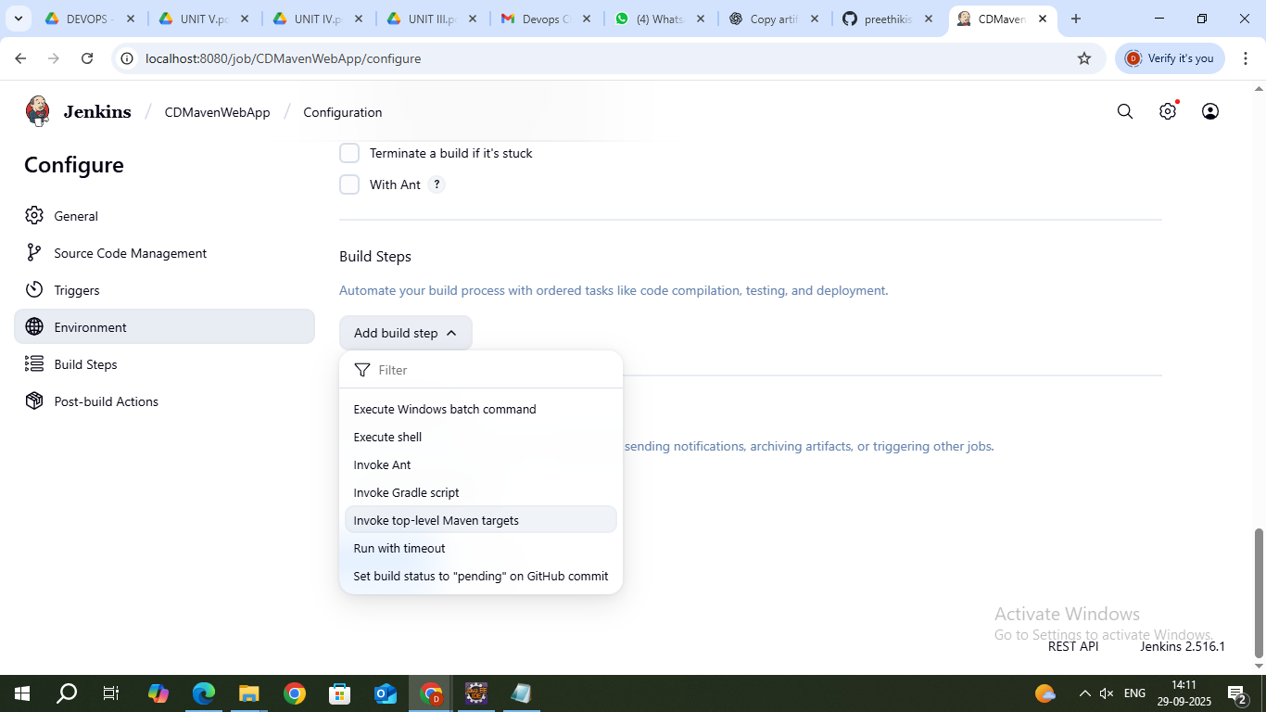

1. Select the maven version and goals as clean and package

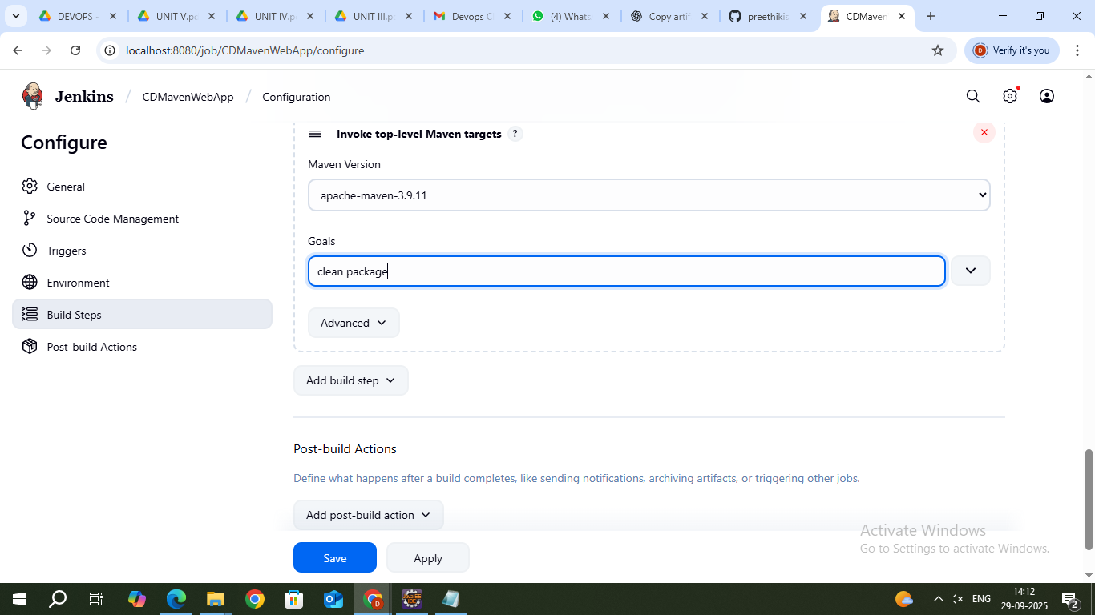

1. In post build steps choose Deploy war/ear to a container and give the information about the war file as target/*.war and the ContextPath as CDMavenWebApp

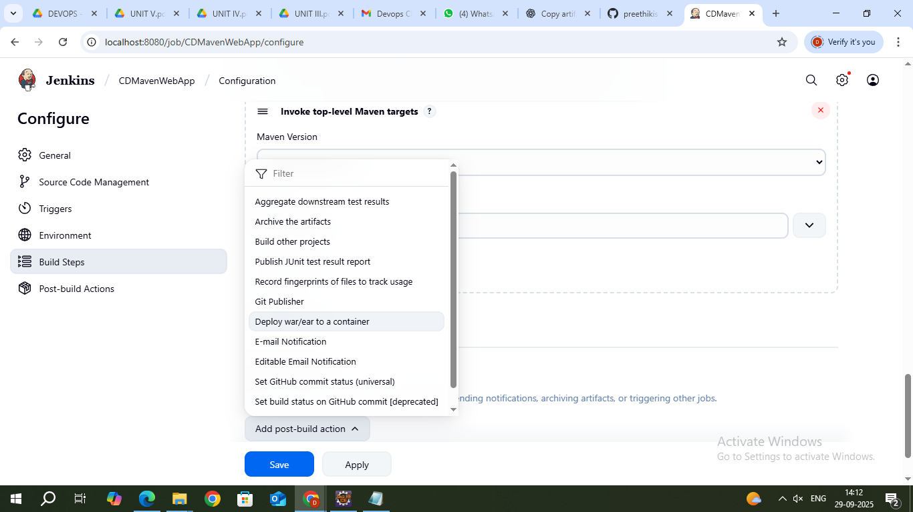

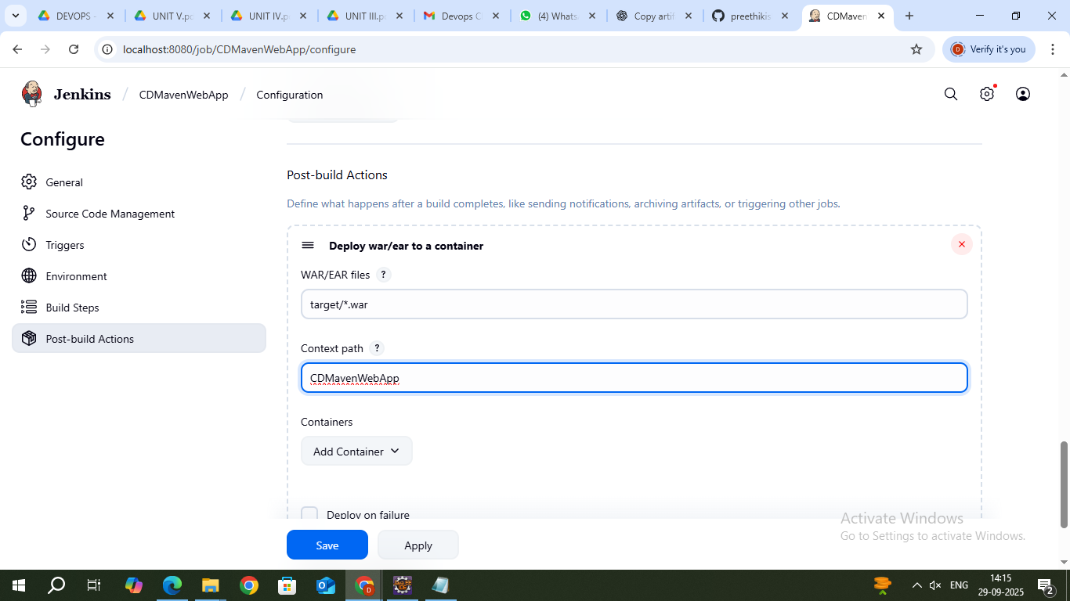

1. Add the container as select the server Tomcat 9.0 and add the credentials of Tomcat and provide the url of Tomcat as <http://localhost:8005>

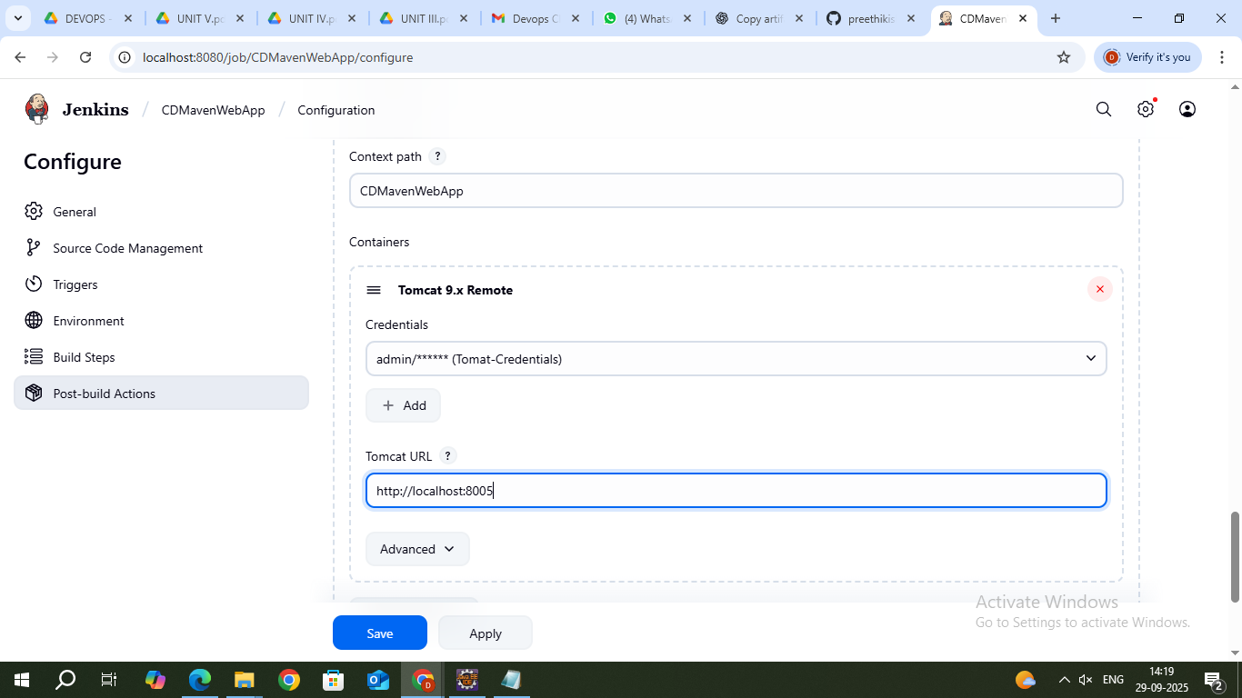

1. Click Apply and Save
2. Click Build Now for instant build

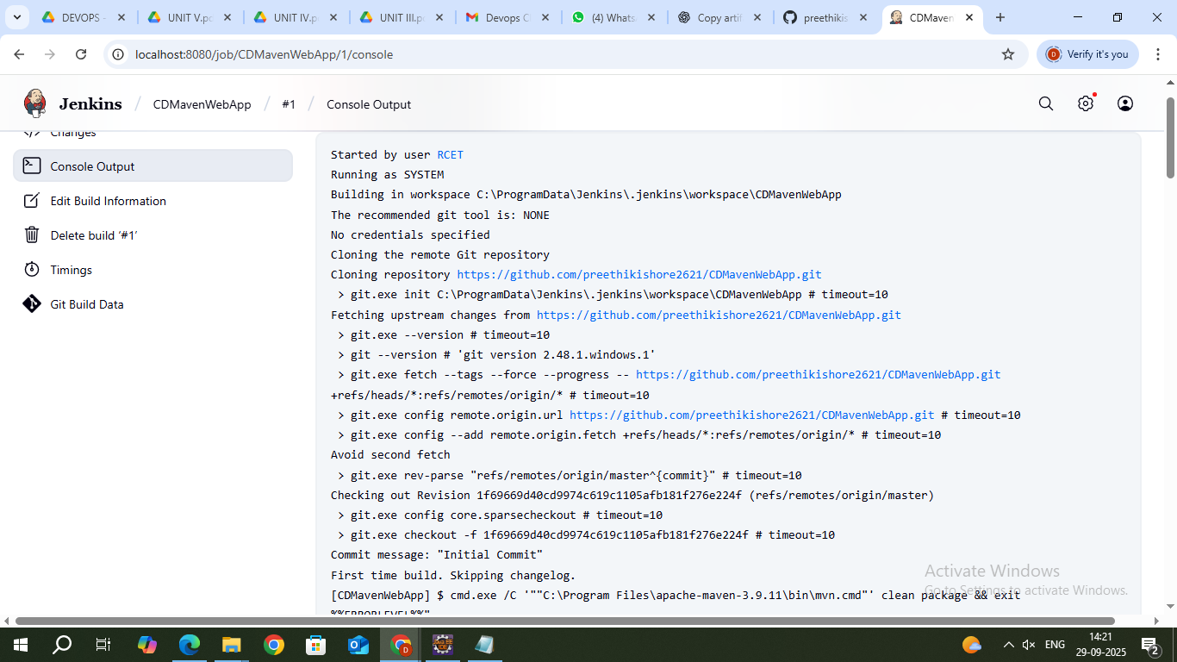

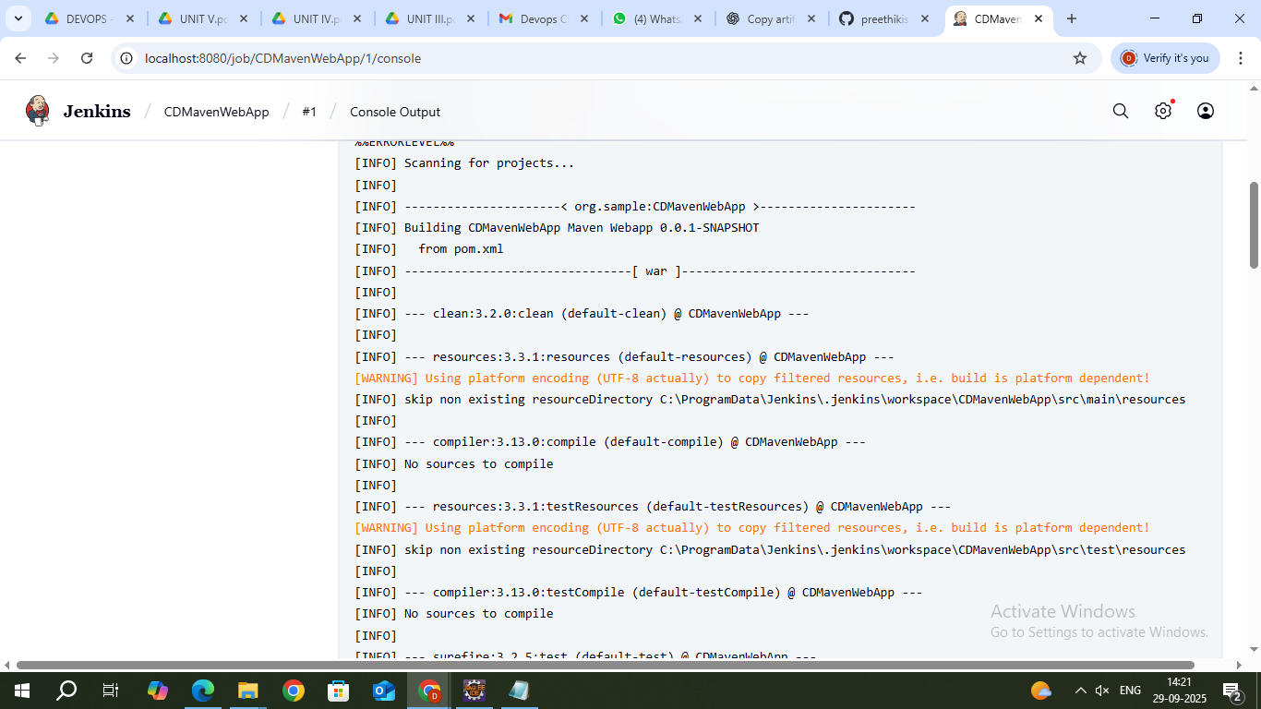

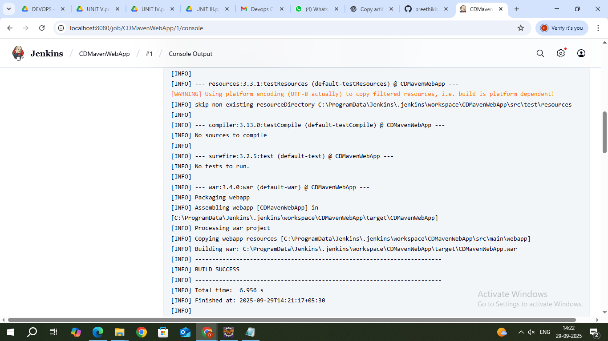

**RESULT:**

Thus the Jenkins CD pipeline was successfully created and executed, automatically deploying the application after a successful build.

**Ex.No.: 6 Create an Ansible playbook for a simple web application infrastructure**

**AIM:**

To set up a basic web server (e.g., Apache or Nginx), deploy an HTML file, and ensure the service is running using Ansible.

**PROCEDURE:**

**Step 1:** Set Up Ansible Environment

Install Ansible on your control node (e.g., using sudo apt install ansible or sudo yum install ansible).  
Ensure passwordless SSH access to your target nodes (managed hosts).  
**Step 2:** Create Inventory File

Create a file named hosts.ini with the IP addresses or hostnames of your target machines.

[webservers]

192.168.56.10

192.168.56.11

Save this file in your working directory.

**Step 3:** Create the Ansible Playbook

Create a file named web_setup.yml.

---

- name: Setup simple web application infrastructure

hosts: webservers

become: yes

tasks:

- name: Install Apache Web Server

apt:

name: apache2

state: present

when: ansible_os_family == "Debian"

- name: Install HTTPD (for RHEL/CentOS)

yum:

name: httpd

state: present

when: ansible_os_family == "RedHat"

- name: Ensure Apache/HTTPD is started and enabled

service:

name: "{{ 'apache2' if ansible_os_family == 'Debian' else 'httpd' }}"

state: started

enabled: true

- name: Deploy sample index.html

copy:

dest: /var/www/html/index.html

content: "<h1>Welcome to the Web Server</h1>"

**Step 4:** Run the Playbook

Use the following command to run the playbook:

**OUTPUT:**

**ansible-playbook -i hosts.ini web_setup.yml**

**PLAY [Setup simple web application infrastructure] \*\*\*\*\*\*\*\*\*\*\*\*\*\*\*\*\*\*\*\*\*\*\*\*\*\*\*\*\***

**TASK [Gathering Facts] \*\*\*\*\*\*\*\*\*\*\*\*\*\*\*\*\*\*\*\*\*\*\*\*\*\*\*\*\*\*\*\*\*\*\*\*\*\*\*\*\*\*\*\*\*\*\*\*\*\*\*\*\*\*\*\*\***

**ok: [192.168.56.10]**

**ok: [192.168.56.11]**

**TASK [Install Apache Web Server] \*\*\*\*\*\*\*\*\*\*\*\*\*\*\*\*\*\*\*\*\*\*\*\*\*\*\*\*\*\*\*\*\*\*\*\*\*\*\*\*\*\*\*\*\*\*\***

**changed: [192.168.56.10]**

**changed: [192.168.56.11]**

**TASK [Ensure Apache/HTTPD is started and enabled] \*\*\*\*\*\*\*\*\*\*\*\*\*\*\*\*\*\*\*\*\*\*\*\*\*\*\*\*\*\***

**changed: [192.168.56.10]**

**changed: [192.168.56.11]**

**TASK [Deploy sample index.html] \*\*\*\*\*\*\*\*\*\*\*\*\*\*\*\*\*\*\*\*\*\*\*\*\*\*\*\*\*\*\*\*\*\*\*\*\*\*\*\*\*\*\*\*\*\*\*\***

**changed: [192.168.56.10]**

**changed: [192.168.56.11]**

**PLAY RECAP \*\*\*\*\*\*\*\*\*\*\*\*\*\*\*\*\*\*\*\*\*\*\*\*\*\*\*\*\*\*\*\*\*\*\*\*\*\*\*\*\*\*\*\*\*\*\*\*\*\*\*\*\*\*\*\*\*\*\*\*\*\*\*\*\*\*\*\*\***

**192.168.56.10 : ok=4 changed=3 unreachable=0 failed=0**

**192.168.56.11 : ok=4 changed=3 unreachable=0 failed=0**

#### RESULT:

Thus the Ansible playbook was executed successfully, installing the web server, deploying the HTML page, and ensuring the service is running on all target machines.

**Ex.No.: 7 Build a simple application using Gradle**

**AIM**:

To develop a simple application using Gradle as the build automation tool, demonstrating the process of project setup, dependency management, compilation, testing, and packaging.

**PROCEDURE:**

**INSTALLATION OF GRADLE:**

Gradle is a Java based tool. Hence the java 8 or higher version must be installed before installing Gradle.

**Step 1:** Visit the official page for Gradle <https://gradle.org/install/>

**Step 2:** Select the binary-only option for downloading the gradle zip file.

**Step 3:** Extract the file at the desired location.

**Step 4:** Configure the environment variable. Click on the path and Edit it by adding the path of gradle

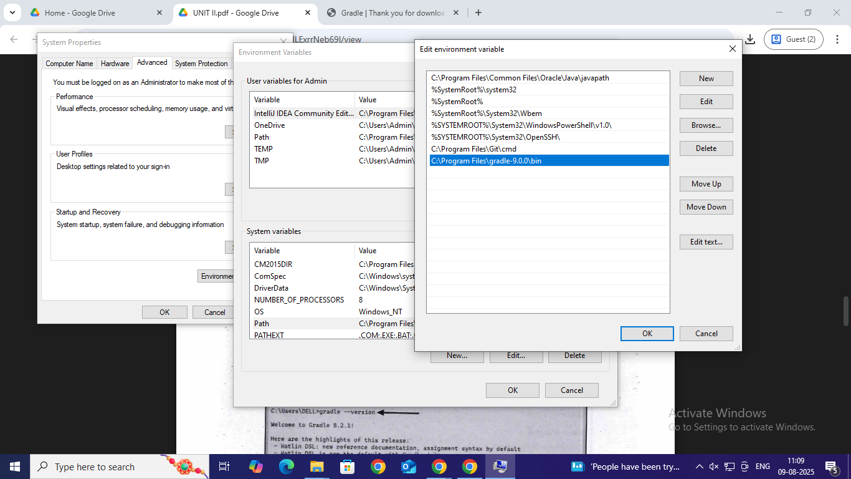

**Step 5:** Open command prompt and issue the command gradle --version. It will display the version of gradle

**Building Simple Application using Gradle**

**Step 1:** To create a new Gradle project with the Eclipse IDE, select the File New Other…​ menu entry and select Gradle/Gradle Project.

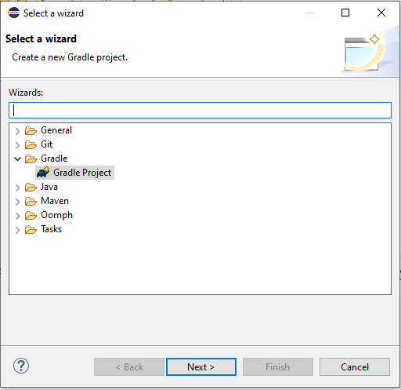

**Step 2:** Click on the Next > button.

**Step 3:** Enter the name of the Gradle project and Click Finish

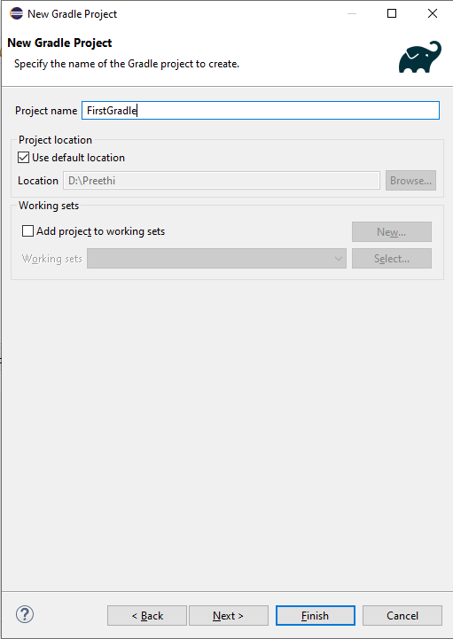

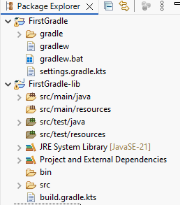

A new Gradle project will be created with the above mentioned directories.

**Creating Gradle using Command prompt:**

**Step 1:** We can create Gradle project using command prompt using the command-line by missing the command **gradle init**

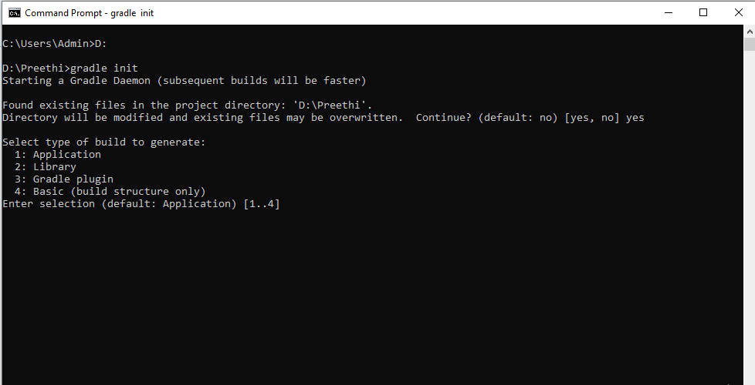

**Step 2:** Enter the build type as 2 for application

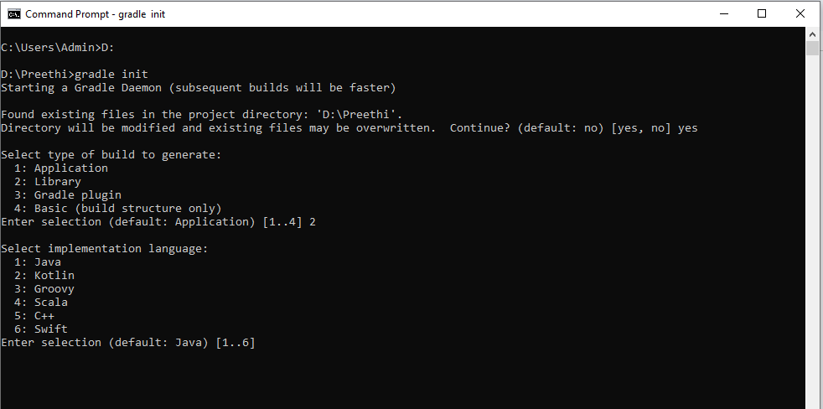

**Step 3:** Enter 1 for selecting Java and Enter the default version and then the name of the project.

**Step 4:** Select the Build Script as Groovy and select the test Framework as 1

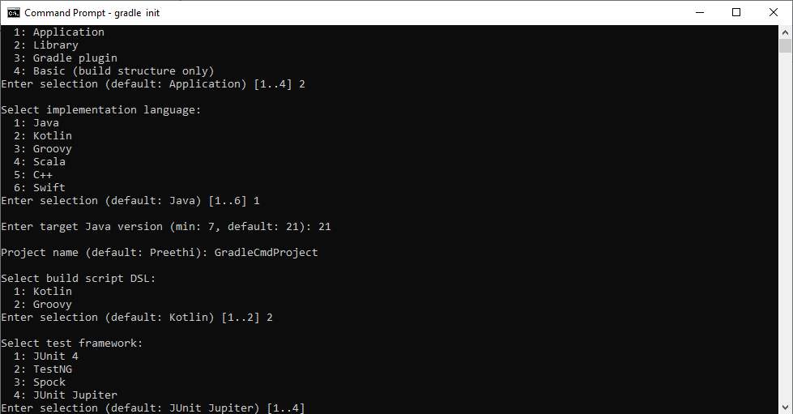

**Step 5:** Enter no to generate build using new APIs

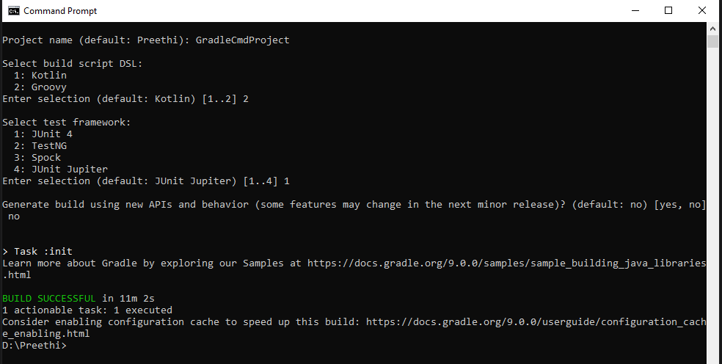

**RESULT:**

Thus the Gradle build was completed successfully by compiling the application and generating the build artifacts without errors.

**Ex.No.: 8 Install Ansible and configure ansible roles and to write playbooks**

**AIM**:

To install and configure Ansible on a control machine, create reusable Ansible roles, and write effective playbooks for automating the configuration and management of servers.

**PROCEDURE:**

**Stage 1: Set Up WSL on Windows**

**Step 1:** Enable WSL

Open PowerShell as Administrator and run:

wsl --install

This will:

Enable WSL features  
**Step 2:** Install Ubuntu (by default)  
**Step 3:** Restart your computer  
**Step 4:** Launch Ubuntu

After restart, search for "Ubuntu" in your Start menu and launch it.

Create a username and password for your Linux environment.

**Stage 2:: Install Ansible inside WSL (Ubuntu)**

**Step 1:** Update and install Ansible

Run these commands inside the Ubuntu (WSL) terminal:

sudo apt update

sudo apt install ansible -y

**Step 2:** Verify installation

ansible --version

**Stage 3: Create a Simple Web Server Role and Playbook**

**Step 1:** Create project folder and role structure

mkdir -p ~/ansible-role-lab/roles/webserver/{tasks,files}

cd ~/ansible-role-lab

**Step 2:** Create inventory file

Create a file called hosts.ini:

[webservers]

192.168.56.10 ansible_user=ubuntu ansible_ssh_private_key_file=~/.ssh/id_rsa

Replace the IP address and SSH details with your actual Linux target VM.

**Step 3**: Create role task file

Create roles/webserver/tasks/main.yml:

---

- name: Install Apache

apt:

name: apache2

state: present

when: ansible_os_family == "Debian"

- name: Start Apache

service:

name: apache2

state: started

enabled: true

**Step 4:** Create the main playbook file

Create site.yml in ~/ansible-role-lab:

---

- name: Configure web server using role

hosts: webservers

become: yes

roles:

- webserver

**Stage 4: Run the Playbook**

**Step 1:** Run the playbook from your WSL terminal

cd ~/ansible-role-lab

ansible-playbook -i hosts.ini site.yml

**OUTPUT:**

PLAY [Configure web server using role] ******************************************

TASK [Gathering Facts] *********************************************************

ok: [192.168.56.10]

TASK [webserver : Install Apache] **********************************************

changed: [192.168.56.10]

TASK [webserver : Start Apache] ************************************************

changed: [192.168.56.10]

PLAY RECAP *********************************************************************

192.168.56.10 : ok=3 changed=2 unreachable=0 failed=0

**RESULT:**

Thus the Ansible was successfully installed on Windows using WSL and a role-based playbook was created and executed to install and configure the Apache web server on the target machine.